INSTITUTO TECNOLÓGICO Y DE ESTUDIOS
SUPERIORES DE OCCIDENTE
Reconocimiento de Validez Oficial de Estudios de Nivel Superior según Acuerdo Secretarial 15018, publicado en el Diario Oficial de la Federación el 29 de noviembre de 1976
Especialidad en Sistemas Embebidos.
Test and validation of vehicle communication protocols and smart-home communication protocols for its integration
Tesis que para obtener el grado de
Especialista en Sistemas Embebidos
presenta
Ing. Francisco Romero Valle
Director de Tesina
Dr. Luis Rizo Domínguez
Tlaquepaque, Jalisco, Julio 2017

Dedication & Acknowledgments

I would first like to thank to CONACYT and Continetal Automotive Periferico for its support in order to study the specialty in embedded systems. In second place but not less important I want to thanks to my mother Indira Briseida Valle Nolasco and my sister Indira Briseida Romero Valle that has support me all my studing life cycle.

Abstract

The IoT has been implemented in personal devices like smat-watch, smart-band and smartphone. The last years the IoT technology has been extended to homes, but now days the IoT has a development delay for automotive industry. This document exposes four communication technologies to allow vehicles to communicate with smart-homes.

In this document, CAN and LIN protocols are explained and tested to validate and understand the functionality and integration of both protocol within a real vehicle. Also, IEEE 802.15.4 stardard is explained and tested to validate the connection and data transmission process between a full functional device and a reduced functional device. Finally, the Tread and CoAP protocols are implemented and tested to validate the connection and data transmission between a border router and end-device in order to test on communication protocol used in smart-homes.

Finally the implementation and test results are discussed to explain the limitations and problem that can happen in development process of protocol implementations.

List of Figures

Figure 1. Vehicle Wired Network. iii
Figure 2. Integration of Bluetooth classic to a vehicle network. iv
Figure 3. Integration of Bluetooth Low Energy to a vehicle network. iv
Figure 4. Ducati Multistrada Link Application [10]. v
Figure 5. SHH Examples (Nest Protect, onHub and Nest Thermostat). v
Figure 6. Mesh Network Topology. vi
Figure 7. Data transmission between Coap Network and WWW Network. vii
Figure 8. Nest - Your home in your hand [11]. vii
Figure 9. Proposed Merge of Networks. viii
Figure 10. OSI Model Abstract Layers. ix
Figure 11. Peer-to-Peer communication with OSI Model. x
Figure 12. CAN in the OSI Model. xiii
Figure 13. CAN Transceiver. xiii
Figure 14. CAN Bus Line. xiv
Figure 15. CAN Signal. xv
Figure 16 Standard CAN Data Frame. xv
Figure 17. Control Field. xvi
Figure 18. Acknowledge Field. xviii
Figure 19. Nominal Bit Time. xix
Figure 20 Phase error of edge. xix
Figure 21. LIN Network Topology. xxi
Figure 22. LIN Transceiver. xxi
Figure 23. LIN Bus Line. xxii
Figure 24. LIN Signal. xxiii
Figure 25. LIN Data Frame. xiii
Figure 26. LIN Data Frame Transmission. xiii
Figure 27. LIN Sync Field. xxiv
Figure 28. LIN Protected Identifier Field. xxv
Figure 29. LIN Response. xxv
Figure 30. Thread in the OSI Model. xxvi
Figure 31. Supported Topologies in 802.15.4 protocol. xxvii
Figure 32. IEEE 802.15.4 Direct Mode Transmission. xxix
Figure 33. IEEE 802.15.4 Indirect Mode Transmission. xxx
Figure 34. IEEE 802.15.4 PHY & MAC Data Frame. xxxi
Figure 35. Thread Network Topology Example. xxxiii
Figure 36. Open BeeKit software. xlii
Figure 37. Select Codebase in BeeKit. xlii
Figure 38. Chose codebase in BeeKit. xliii
Figure 39. Create Project in BeeKit. xliii
Figure 40. Select BeeKit Project Location and Template in BeeKit. xliv
Figure 41. Select Development Board in BeeKit. xliv
Figure 42. Select Processor in BeeKit. xlv
Figure 43. Chose Modules in BeeKit. xlv
Figure 44. Enable UART in BeeKit. xlvi
Figure 45. Select Protocol Version in BeeKit. xlvi
Figure 46. Select Channels in BeeKit. xlvii
Figure 47. Configure PAN ID. xlvii
Figure 48. Set Maximum of Pending Packets. xlviii
Figure 49. Export to CodeWarrior. xlviii
Figure 50. Kinetis Connectivity Project Cloner l
Figure 51.Import Project in KDS. li
Figure 52. Source and Header files location for Thread practice. lii
Figure 53.File destination of sensor modules for Thread practice. lii
Figure 54. KDS build and download button. liii
Figure 55. LIN Frame data transmission. liv
Figure 56. Noise in LIN Frame data transmission. liv
Figure 57. CAN Signals sent to test bench. lvi
Figure 58. Tread communication Log. lvii

List of Tables

Table 1. Data Length Code. xvii
Table 2. NBT Segment Duration. xx
Table 3. IEEE 802.15.4 Radio Frequency Modulation. xxviii
Table 4. IEEE 802.15.4 Full functional device characteristics. xxviii
Table 5. IEEE 802.15.4 Reduced functional device characteristics. xxviii
Table 6. IEEE 802.15.4 PIB Characteristics examples. xxxii
Table 7. Hardware required to execute the practices. xxxvi
Table 8. Softwarerequired to execute the practices. xxxvii
Table 9. Functions required to transmit data in LIN network with SAM V71 board. xxxviii
Table 10. LIN Initializer Function Requirements. xxxviii
Table 11. Send LIN Frame Function Requirements. xxxiv
Table 12. Information to be Determined from Test Bench. xl
Table 13. IEEE 802.15.4 Coordinator Requirements xlix
Table 14. IEEE 802.15.4 End Device Requirements xlix
Table 15. CAN IDs found in test bench. lv
Table 16. CAN segments values to calculate baud rate. lv

List of Abbreviations and Acronyms

IoT | Internet of Thinks
IP | Internet Protocol
CAN | Controller Area Network
LIN | Local Interconnect Network
CoAP | Constrained Application Protocol
NXP | Next Experience (Company)
ECU | Electronic Control Unit
UART | Universal Asynchronous Receiver/Transceiver
HTTP | Hypertext Transfer Protocol
OBD | On Board Diagnostics
WWW | World Wide Web
A2DP | Advanced Audio Distribution Profile
HFP | Hands Free Profile
VDP | Video Distribution Profile
Wi-Fi | Wireless Fidelity
ANCS | Apple Notification Center Service
SHH | Smart Home Hub
OSI | Open System Interconnect
SAR | Segmentation and reassembly
CAN-H | CAN High
CAN-L | CAN Low
SOF | Start of Frame
RTR | Remote Transmission Request
CRC | Cyclic Redundancy Check
ACK | Acknowledge
NBR | Nominal Bit Rate
NBT | Nominal Bit Time
MCU | Microcontroller Unit
BRP | Baud Rate Prescaler
IPT | Information Processing Time
OTP | One Time Programmable
LSB | Less Significant Bit
MSB | Most Significant Bit
PAN | Personal Area Network
PIB | PAN Information Base
UDP | User Datagram Protocol
DTLS | Datagram Transportation Layer Security
REED | Router-Eligible End Device
SED | Sleeping End Device
IPv6 | Internet Protocol version 6
6LoWPAN | IPv6 over Low Power Wireless Personal Area Network
MAC | Media Access Control
FFD | Full Function Device
RFD | Reduced Function Device
PHY | Physical
PPDU | PHY Protocol Data Unit
PSDU | PHY Service Data Unit
MPDU | MAC Protocol Data Unit
MSDU | MAC Service Data Unit
MFR | MAC Footer
BPSK | Binary Phase Shift Keying
ASK | Amplitude Shift Keying
O-QPSK | Offset Quadrature Phase Shift Keying
IDE | Integrated Development Environment
SM | State Machine
API | Application Programming Interface
KDS | Kinetis Design Studio

Table of Contents

Abstract iv
List of Figures v
List of Tables vii
List of Abbreviations and Acronyms viii
1. Introduction 1
2. Background 3
3. Theoretical Framework 9
3.1. Open System Interconnect Model (OSI Model) 9
3.1.1. Physical Layer 10
3.1.2. Data Link Layer 10
3.1.3. Network Layer 11
3.1.4. Transport Layer 11
3.1.4.1. Transport Layer Modes 11
3.1.4.1.1. TP0 11
3.1.4.1.2. TP1 11
3.1.4.1.3. TP2 11
3.1.4.1.4. TP3 11
3.1.4.1.5. TP4 12
3.1.5. Session Layer 12
3.1.6. Presentation Layer 12
3.1.7. Application Layer 12
3.2. CAN 12
3.2.1. CAN Transceiver 13
3.2.2. CAN Bus Line 14
3.2.3. CAN Signal 14
3.2.4. CAN Data Frame 15
3.2.4.1. Start of Frame (SOF) 15
3.2.4.2. Arbitration Field 16
3.2.4.2.1. Identifier 16
3.2.4.2.2. Remote Transmission Request (RTR) 16
3.2.4.3. Control Field 16
3.2.4.4. Data Field 17
3.2.4.5. Cyclic Redundancy Check (CRC) 17
3.2.4.6. Acknowledge (ACK) Field 17
3.2.5. Bit Timing Requirements 18
3.2.5.1. SYNC_SEG 19
3.2.5.2. PROP_SEG 19
3.2.5.3. PHASE_SEG1 and PHASE_SEG2 19
3.2.5.4. Sample Point 20
3.2.5.5. Information Processing Time (IPT) 20
3.2.5.6. Time Quantum 20
3.3. LIN Network 20
3.3.1. LIN Transceiver 21
3.3.2. LIN Bus Line 22
3.3.3. LIN Signal 22
3.3.4. LIN Frame 23
3.3.4.1. Master Header 24
3.3.4.1.1. Break Field 24
3.3.4.1.2. Sync Byte Field 24
3.3.4.1.3. Protected Identifier Field 24
3.3.4.2. Response 25
3.4. Thread 26
3.4.1. OSI Model 26
3.4.2. IEEE 802.15.4 27
3.4.2.1. Radio Frequency 27
3.4.2.2. Type of devices 28
3.4.2.3. Transmission Modes 29
3.4.2.3.1. Direct Mode 29
3.4.2.3.2. Indirect Mode 29
3.4.2.4. Data Frame 30
3.4.2.4.1. MAC Header 31
3.4.2.4.2. MAC Service Data Unit (MSDU) 31
3.4.2.5. MAC PAN Information Base (PIB). 32
3.4.3. Topology 32
3.4.3.1. Border Router 33
3.4.3.2. Router or Leader 33
3.4.3.3. Router-Eligible End Device (REED) 33
3.4.3.4. Sleepy End Device (SED) 34
4. Design of product 35
4.1. LIN 36
4.1.1. Application and Conditions 36
4.1.2. Process 36
4.1.2.1. Create LIN initializer function 37
4.1.2.2. Create send LIN frame function 38
4.2. CAN 38
4.2.1. Application and Conditions 38
4.2.2. Process 38
4.2.2.1. Analyze CAN Network from Test Bench Equipment 39
4.2.2.2. Create SAM V71 software 39
4.3. IEEE 802.15.4 40
4.3.1. Application and Conditions 40
4.3.2. Process 40
4.3.2.1. Create base code with BeeKit 40
4.4. Thread 49
4.4.1. Application and Conditions 49
4.4.2. Process 49
4.4.2.1. Clone End Device project 49
4.4.2.2. Configure KDS 50
4.4.2.3. Copy Sensor Files 50
4.4.2.4. Source code modifications on project 51
5. Results 53
5.1. LIN 53
5.2. CAN 54
5.3. IEEE 802.15.4 55
5.4. Thread 56
6. Discussion 57
7. Conclusion 58
8. References 59

Introduction

Internet of Things (IoT) “is a global infrastructure for the information society, enabling advanced services by interconnecting (physical and virtual) things based on existing and evolving interoperable information and communication technologies” [1]. The IoT technology allows common devices to be controlled and monitored over the internet. According to the Internet of Things Consortium, the number of IoT connected devices will be increased from 10.3 billion in 2014 to 29.5 billion in 2020 [2]. This last decade the concept of IoT has been adjusted to the transformation of common devices into “smart devices” like smartwatches, smart tv's, smartphones, smart bands and smart homes among others, with the help of standard and new wireless network communication protocols. The current development of “smart devices” focuses on domotics to automatize homes and wearable embedded devices to track fitness and/or health information. On the other hand, the automotive industry is delayed in terms of IoT compared to others smart devices even when the automotive sector has a longer time of being created.

For more than 20 years, the global automotive industry has been using Controller Area Network (CAN) and Local Interconnect Network (LIN) as the main wired internal communication medium for control and diagnosis of every electronic component in the vehicle’s infrastructure. The forecast indicates that these trends will not be replaced in the next years since both protocols are relatively inexpensive and require only 2 wires to connect all electronic components. CAN is a serial communication protocol that efficiently supports distributed real-time system with a very high level of communication [3] and LIN complements the existing portfolio for automotive multiplex networks [4]. As these protocols were created before the IoT concept, wireless communication was not considered. Therefore, new wireless protocols must be incorporated to allow the integration of CAN and LIN with IoT. The new protocol must determine the source and destination message packet for security purposes and automatic message routing, this means that the new protocol must support the IP protocol as well.

Thread protocol was specially designed by the Thread Group for connected home applications, where an IP-based network is desired in order to provide the best way to connect and control any electrical product at home. Constrained Application Protocol (CoAP) protocols have been developed to integrate IoT to homes in an easy way [5]. The advantages of these Thread and CoAP protocols are the low energy consumption, the identification and location of every device in the network and the communication between devices with Representational State Transfer architecture (REST).

This work presents the automotive network communication and new smart-home protocols integration, together they improve the car´s user experience (UX). Also, communication tests will be showed as evidence of the integration feasibility between protocols. These tests will be executed on NXP hardware. Note that, NXP is the 5th largest semiconductor company and 1st worldwide electronic provider for automotive industry and communication processors [6].

One of the main concerns of drivers is the security and integrity of their vehicles. CAN network is commonly used for security systems such as airbag control. This is the reason why in this document CAN protocol will only be used for diagnosis and actions without considering the security risk. LIN on another hand, is commonly used for non-risky actions like electric window control, infotainment control, and several light control modules. Thus, LIN protocol is also considered.

Background

Vehicle communication has evolved over the years according to the commercially available technology. The first steps in vehicle communication occurred in 1983 with the implementation of the CAN bus, developed by Robert Bosch GmbH [7], and the LIN Protocol, released in 1999 by LIN Consortium [4]. These two technologies allow open communication between every electric component with other electronic components within the vehicle network. Figure 1 shows the CAN and LIN network distribution.

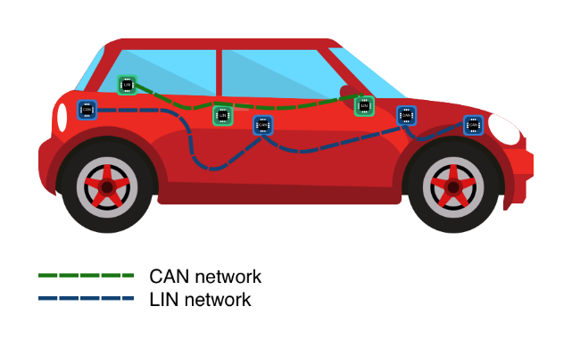
Figure 1. Vehicle Wired Network.

In 2001, the next big step in vehicle communication was the implementation of Bluetooth Classic for hands-free options and features [8] as well as Audio Advanced Distribution Profile (A2DP) and Hands Free Profile (HFP). The consolidation of these three technologies allowed vehicles to communicate with multimedia devices in order to transfer and reproduce audio files wirelessly.
In addition, these profiles grant cell phone users the comfort of answering and hanging up calls without the direct interaction of the cell phone but instead, the interaction is with the car. Calls are received through the vehicle speakers, improving safety for drivers who use cell phones while driving. Bluetooth technology provides the first wireless communication in vehicles. Figure 2 shows how the coexistence of CAN and LIN networks with the Bluetooth network.
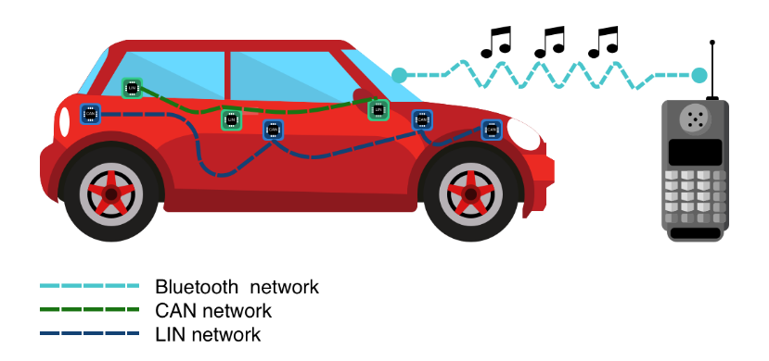
Figure 2. Integration of Bluetooth classic to a vehicle network.

Once smartphones were invented, new use cases were implemented in vehicles with Bluetooth Low Energy and new Bluetooth Classic Profiles. This new technology extends the vehicle´s capabilities by allowing users to track the vehicle´s information through a smartphone or control features of the vehicle. Figure 3 show the available networks in modern vehicles.

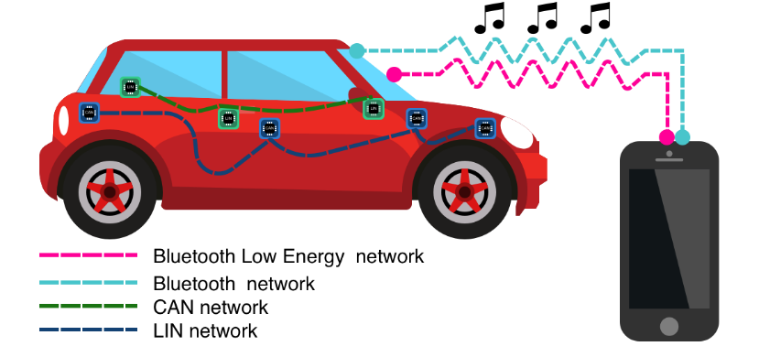
Figure 3. Integration of Bluetooth Low Energy to a vehicle network.

One example of these new use cases is Ducati Multistrada Link Application [9], a mobile application for Android and iOS that allows motorcycle drivers to keep track of information such as gas consumption, revolution per minute average, maximum lean angle and even share this information with friends (Figure 4). These kinds of applications are the first steps for introducing vehicles into IoT, however, the only restriction is that the user must be close to the vehicle for the system to work.

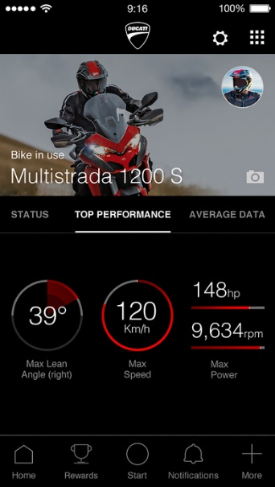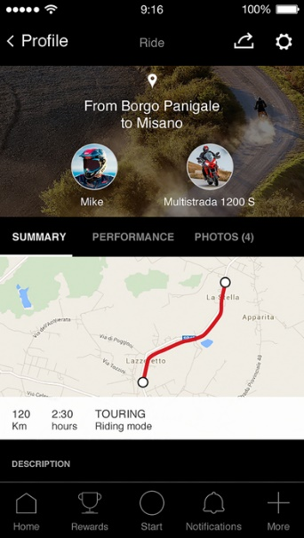
Figure 4. Ducati Multistrada Link Application [10].

The IoT keeps evolving year after year and new technology is being developed and integrated in new products for IoT infrastructure. One of the most emerging products are smart homes devices that support home automation. The main role of Smart Home Hub (SHH) is to work as a gateway for wireless control of the data transmission between devices that can be controlled wirelessly. Figure 5 shows some smart home hub examples.

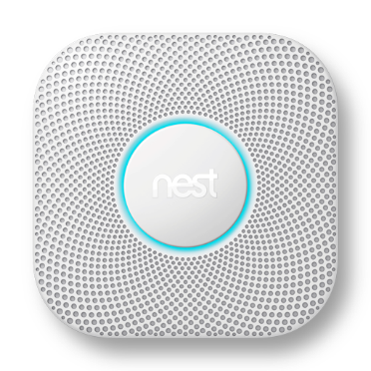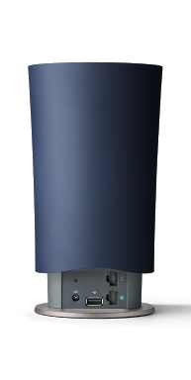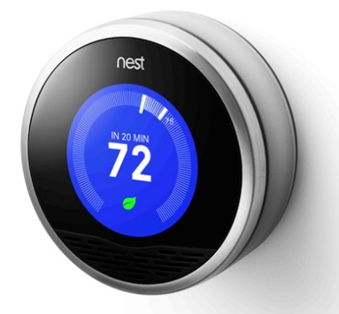
Figure 5. SHH Examples (Nest Protect, onHub and Nest Thermostat).

The Nest Thermostat, is a SHH that keeps track of the temperature and energy consumption of the house to automatically create a schedule of tasks to control the devices connected to its wireless network. The Nest Thermostat keeps the house in the preferred temperature while it reduces the energy consumption and even learns from user preferences to improve its self-functionality.

The most popular SHH, the Nest Thermostat, supports different types of wireless communications protocols like: Bluetooth Low Energy, Zig-bee, Z-Waves, dotdot, Thread, or Constrained Application Protocol (CoAP), among others. Thread protocol is one of the most interesting networks since it has a mesh topology (Figure 6). Every node in the mesh network helps other nodes transmit data information over the entire network and assign a unique Internet Protocol address (IP address) providing the capability to determine the source and destination of any data package transmitted over the Thread network.
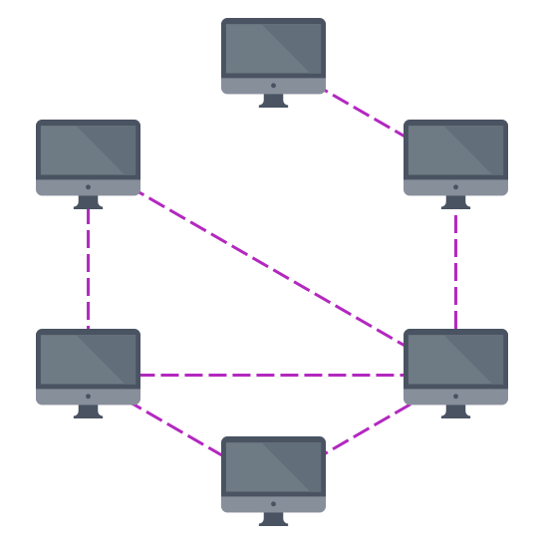
Figure 6. Mesh Network Topology.

Another interesting protocol used by SHH devices, is CoAP due to its capability to support Uniform Resource Identifier (URI) and thus, enable the identification and interaction with a specific resource. CoAP protocol has a similar functionality like Hypertext Transfer Protocol (HTTP), but it is designed for low energy consumption. This similarity between CoAP and HTTP provides the capability to access the Thread Network through the World Wide Web (WWW) Network. Figure 7 shows the data transmission between a smartphone and a Thread/CoAP Network using the Internet Network over WWW and SHH as a gateway.

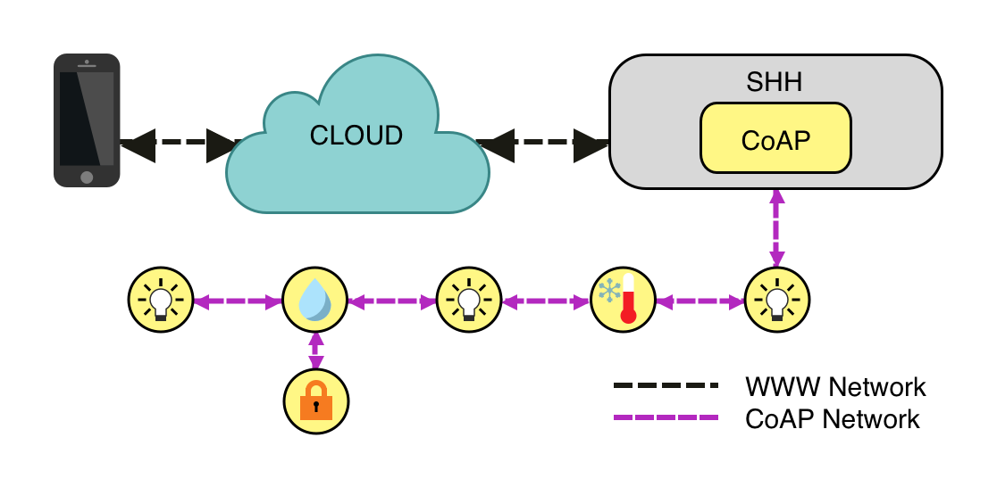
Figure 7. Data transmission between Coap Network and WWW Network.

As can be seen in Figure 7, a SSH can be managed with smartphone applications to control the devices in a house. One example is the App for iOS devices “Nest – Your home in your hands” (Figure 8). The Nest mobile application is just like the Ducati Multistrada Link App, as it allows users to control and monitor features wirelessly, but with the advantage of doing it remotely.

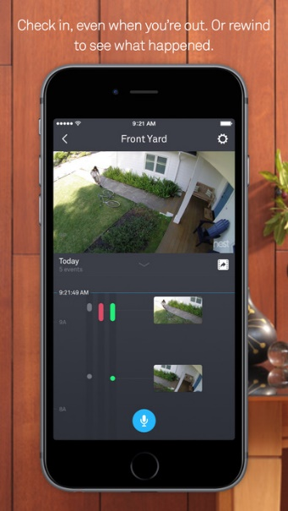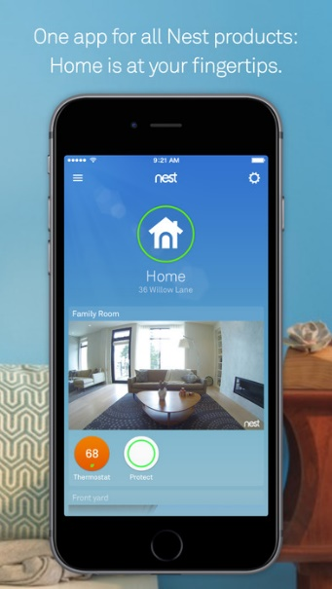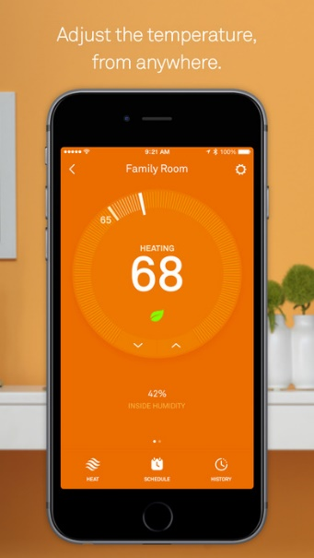
Figure 8. Nest - Your home in your hand [11].

This capability of controlling and monitoring devices connected to the SSH network over the WWW could be used to control and monitor devices in a vehicle in the same way as a light is turn on/off by a SSH, or execute specific actions when the vehicle joins or leaves the SHH network. One use case could be, when a known vehicle arrives home, the vehicle connects to the SHH network and this event triggers actions like: turning on the light of the house, turning on the oven to start cooking dinner or deactivating the security system because SHH knows who is driving the vehicle. Also, the SSH could learn the time when the vehicle leaves and arrives home and thus, set the temperature of the house before the driver arrives home.

The connection between a vehicle and a SHH could be used for security of the vehicle. For example, if owner of the vehicle goes out for a trip and leaves his/her vehicle at home, a notification could be sent to their smartphone to let the person know if somebody can turn on the vehicle. Also, if the vehicle is outside the garage and somebody tries to steal the vehicle, the security system of the house could be triggered in order to alert the police.

This document will explain the components and architecture required to connect CAN and LIN networks with a SSH using Thread and Coap Protocol to execute the previously mentioned use cases and other examples. Figure 9 shows the networks required to connect vehicles with smart homes, where Thread/Coap networks are used to transmit data from SHH to the car and WWW network is used to control the SHH from a smartphone.

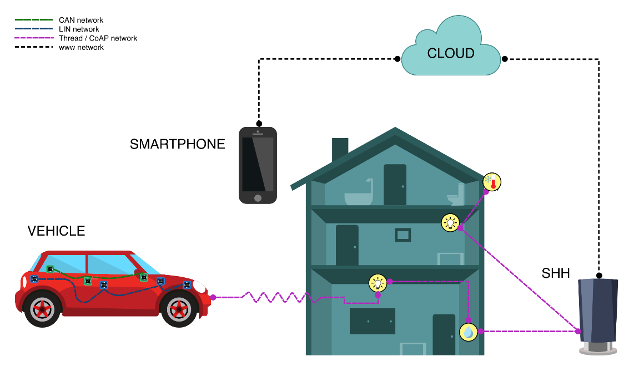
Figure 9. Proposed Merge of Networks.

Theoretical Framework

Open System Interconnect Model (OSI Model)

The OSI Model is a conceptual model divided into 7 abstract layers designed as a standard for telecommunication between electronic systems (Figure 10). It was designed to be implemented in any hardware that requires to communicate with other hardware without regard of the specific internal structure or communication technology. Each abstract layer is designed to meet a specific function in the peer-to-peer telecommunication process (Figure 11). It is important to mention that a protocol does not require to be placed in all layers of the OSI Model. Many protocols only oversee one or two layers and this flexibility allows developers to combine different types of protocols in different network architectures.

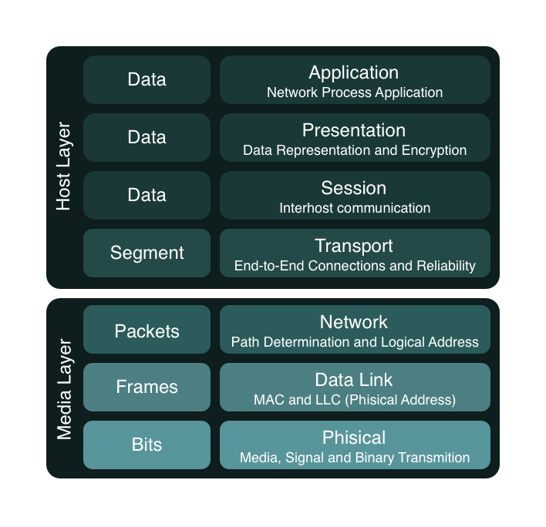
Figure 10. OSI Model Abstract Layers.
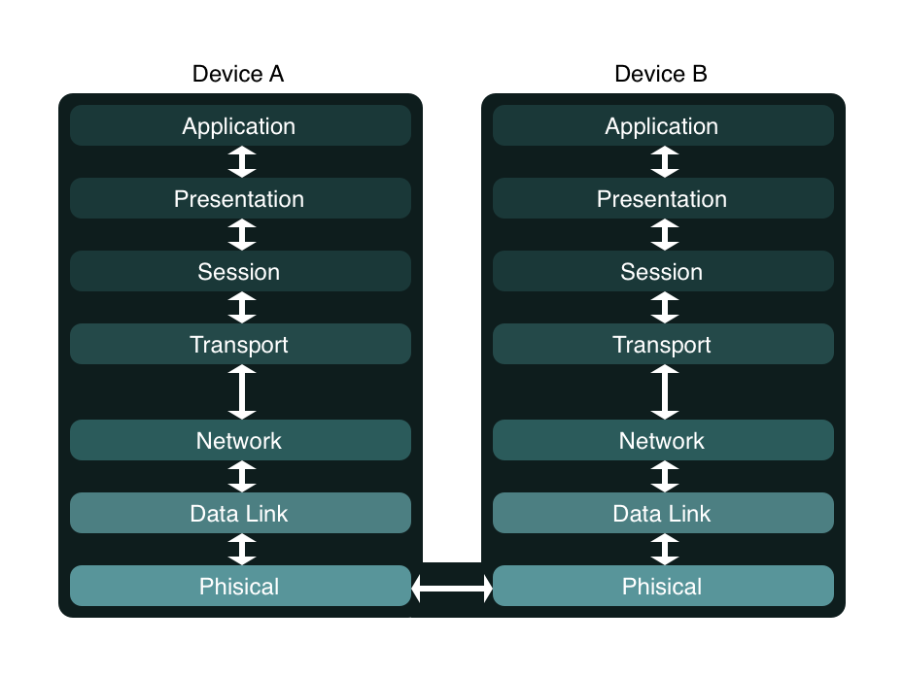
Figure 11. Peer-to-Peer communication with OSI Model.

Physical Layer

This is the physical transmission medium that can be a wire, an optical fiber, or a radio frequency signal; it is placed on the bottom of the OSI Model layers and must meet the electrical specification. This layer is never concerned about the protocol that will be used to transmit data.

Data Link Layer

This layer is in charge of the data transfer between nodes in the network; it determines when to start or finish the connection between two or more devices. Also, the data link is in charge of detecting and possibly correcting errors in message data that can occur in the physical layer as result of interference in the physical connection.

Network Layer

The network layer in charge of providing the logical process required to transfer data packets between two or more nodes in the same network. This layer requires sufficient information to determine the path of the destination node based on the node address.

Transport Layer

The transport layer ensures that data packets will be transferred completely between nodes in the same network. Five modes have been defined depending on the capability of each protocol.

Transport Layer Modes

TP0
Can perform segmentation and reassembly(SAR) of data packets.

TP1
Can perform SAR and execute recovery process.

TP2
Can perform SAR, execute recovery process and execute multiplexing and demultiplexing.

TP3
Can perform SAR, execute recovery process, execute multiplexing, and demultiplexing and provide reliable transport service.

TP4
Can perform SAR, execute recovery process, execute multiplexing, and demultiplexing, provide reliable transport service and retransmit a data packet on timeouts.

Session Layer

The session layer provides the logic to manage and finish connections between nodes in the same network. It is commonly used when authentication is required to transfer private information.

Presentation Layer

This layer oversees the format of the data packet, and can provides encryption and decryption process to transfer sensitive information.

Application Layer

This layer is the closest to the end user, and it is usually the OSI Model layer that interacts with the user, one example is HTTP, which is used to display data from the Internet in web browsers.

CAN

CAN is a serial bus communication protocol located only in the physical and data link layers of the OSI Model (Figure 12). When the data link layer of the CAN Network detects inactive bus, it starts the transmission of a new. Additionally, the errors detection is filtered in this layer providing information to Application layer of the OSI Model. The physical layer of the CAN Network oversees the bit transmission between nodes connected to the same network [3].

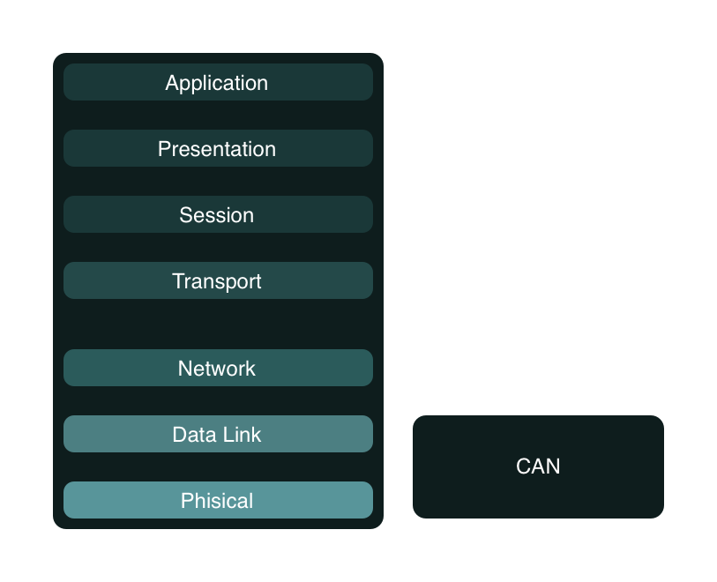
Figure 12. CAN in the OSI Model.

CAN Transceiver

The CAN connection is able thought a specific hardware called transceiver fulfills the function of transmitting and receiving data from the network (Figure 13). This specialized hardware can be directly connected from the CAN Network to the CAN High and CAN Low wires without any extra component like a resistor or capacitor.

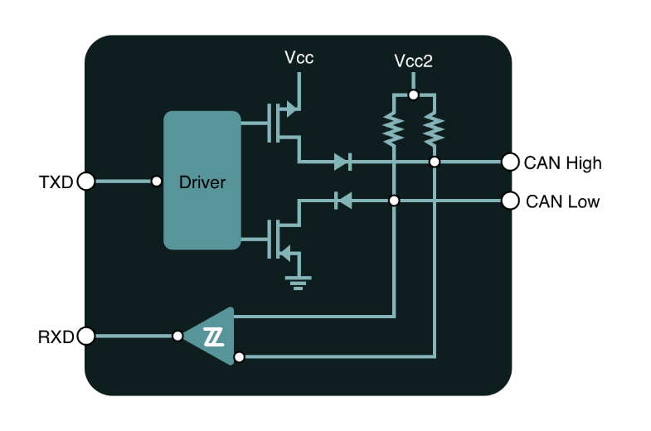
Figure 13. CAN Transceiver.

CAN Bus Line

The CAN bus line is composed of two twisted wires connected with two resistors of 120 Ω, one wire is called CAN High (CAN-H) and the other is called CAN Low (CAN-L). Figure 14 shows how every node (Transceiver) in the network must be connected to the CAN Network.
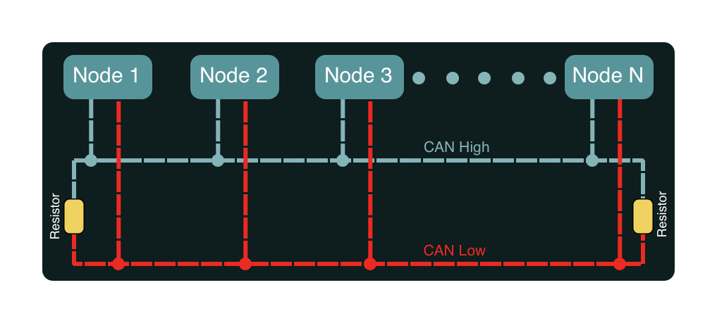
Figure 14. CAN Bus Line.

CAN Signal

The CAN bus transmits data with differential signals that help reduce the external electromagnetic interference (Figure 15). CAN Network defines recessive state when the voltage in CAN-H and CAN-L wires has an approximate voltage of 2.5V; this voltage level represents a logical state of 0. In order to represent a logical state of 1 in the CAN bus, the voltage in the CAN-H wire goes up to 3.5 V and CAN-L goes down to 1.5 V. These voltage levels in both CAN wires is known as a dominant state.
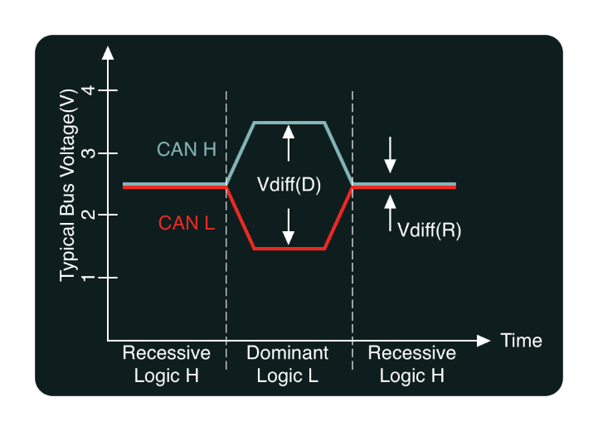
Figure 15. CAN Signal.

CAN Data Frame

The data sent from one transmitter to a receiver over a CAN network is composed of 7 sections (Figure 16).

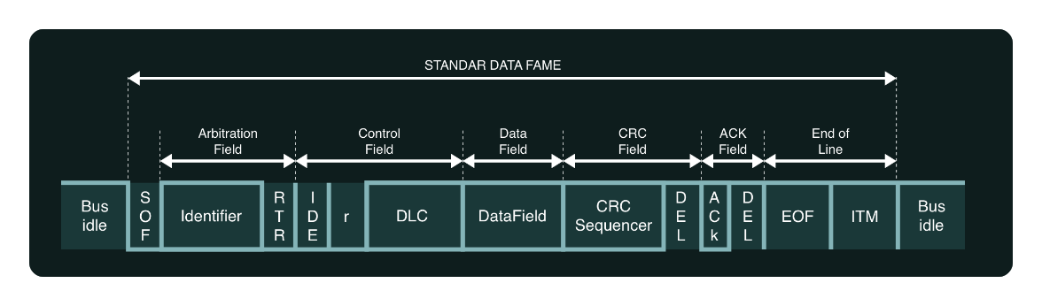
Figure 16 Standard CAN Data Frame.

Start of Frame (SOF)

This frame section marks the start of a message transmission. This frame is detected by a transceiver node when the CAN bus signal changes from a bus idle state (only dominant state) to a recessive state.

Arbitration Field

Identifier

The identifier has a length of 11 bits. The transmission of these bits is in the order of ID10 to ID0 and for the 7 most significant bits, these must not to be in consecutive recessive state [3]. For CAN 2.0A and for CAN 2.0B, the length of the identifier section is 29 bits.

Remote Transmission Request (RTR)

In data frame, this section must be in Dominant bit and it marks the end of an arbitration field.

Control Field

This section consist of 6 bits, were 4 bits are used to determine the length of Data field, and 2 bits are reserved for future expansion (Figure 17). Table 1 shows the code used to determine the length of data field.

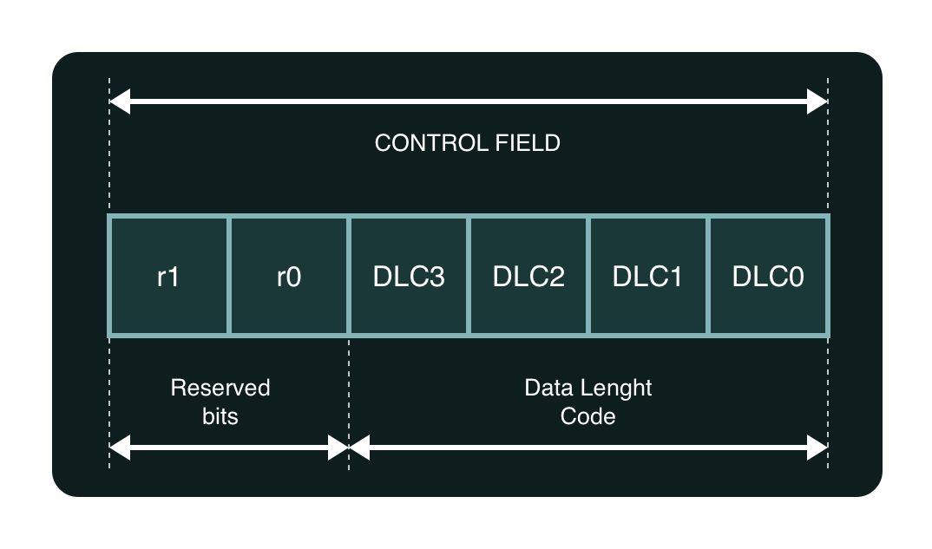
Figure 17. Control Field.
Table 1. Data Length Code.
Data Length Code |  |  |  | Data Byte Count
DLC3 | DLC2 | DLC1 | DLC | Data Byte Count
D | D | D | D | 0
D | D | D | R | 1
D | D | R | D | 2
D | D | R | R | 3
D | R | D | D | 4
D | R | D | R | 5
D | R | R | D | 6
D | R | R | R | 7
R | D | D | D | 8
D = Dominant (bit 0), R = Recessive (bit 1)

Data Field

This section contains the data to be transmitted. The length can be from 0 to 8 bits depending on the bits sent in the control field.

Cyclic Redundancy Check (CRC)

The CRC is used to detect errors in messages, the value transmitted is the result of a checksum of the bytes from the data field represented with 15 bits. After the 15-bit checksum, a delimiter in dominant state is transmitted to announce that the field is complete.

Acknowledge (ACK) Field

This section is two bits in length, where the first bit is called acknowledge slot and second bit is called acknowledge delimiter. If a node in the network determines that that message transmitted is valid, it will send a recessive signal during the Acknowledge Slot (Figure 18).

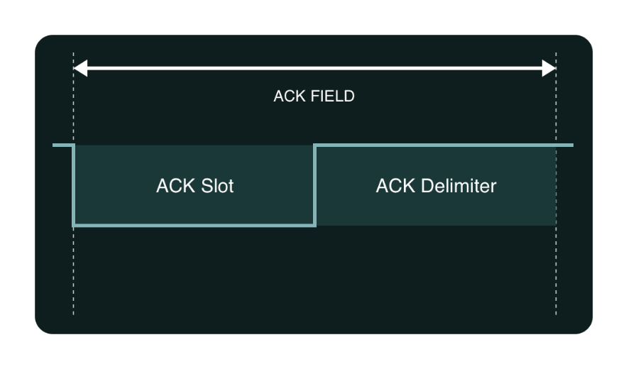
Figure 18. Acknowledge Field.

Bit Timing Requirements

The CAN Network can transmit the data frames in a variety of uniform speeds named Nominal Bit Rate (NBR), which “is the number of bits per second transmitted in the absence of resynchronization by an ideal transmitter” [3] that can calculated with the formula (3-1).

$$NBR=\frac{1}{NBT}$$ | (3-1)

The Nominal Bit Time (NBT) consist of four segments (Figure 19) used to guarantee the correct bit state, even when a physical interference or bus delay exists. The NBT period is the sum of its four segments with formula (3-2).

$$NBT={SYNC_SEG}_{t}+{PROP_SEG}_{t}+{PHASE_SEG1}_{t}+{PHASE_SEG2}_{t}$$ | (3-2)

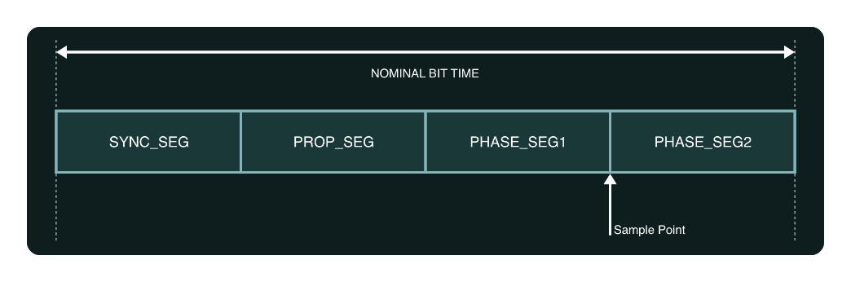
Figure 19. Nominal Bit Time.

SYNC_SEG

This section of the NBT is used by nodes connected to the CAN Network to synchronize with the bus.

PROP_SEG

This section of bit timing is used to atone the physical delay time between nodes.

PHASE_SEG1 and PHASE_SEG2

These sections of the NBT help compensate the phase error of edges (Figure 20). This correction can be done by lengthening PHASE_SEG1 or shortening PHASE_SEG2.
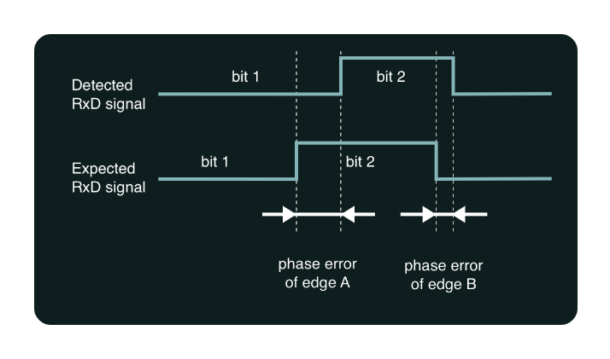
Figure 20 Phase error of edge.

Sample Point

The sample point is where the bus level is read and translated to the corresponding bit state (0 or 1).

Information Processing Time (IPT)

The information processing time is the time segment that starts just after the sample point and is reserved for calculating the corresponding bit state of the sample point.

Time Quantum

Each NBT segment must be “an integer multiplier of a unit of time called Time Quantum” [12]. The duration of a time quantum must be equal to the system clock of CAN network, which is extracted from the Microcontroller Unit (MCU) oscillator or system clock through a prescaler called Baud Rate Scaler (BRS). Each segment in NBT can last a specific number of time quanta specified in Table 2.

Table 2. NBT Segment Duration.
Segment | Duration
SYNC_SEG | $$t_{SYNC_SEG}=1t_{Q}$$
PROP_SEG | $$t_{PROP_SEG}=1{ , 2 . . . 8 t}_{Q}$$
PHASE_SEG1 | $$t_{PHASE_SEG1}=1{ , 2 . . . 8 t}_{Q}$$
PHASE_SEG2 | $$t_{PHASE_SEG2}=MAX( IPT, t_{{PHASE}_{SEG1}})$$

LIN Network

The LIN network emerged as a need for a new serial network for automotive industry, which was cheaper than CAN. The LIN network has a hierarchical single master with multiple slaves model (Figure 21), which allows the execution of multiple tasks with one single request.
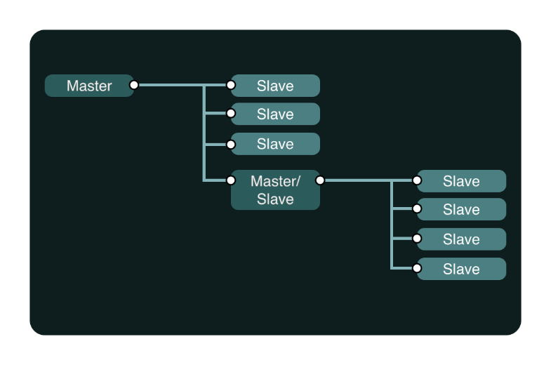
Figure 21. LIN Network Topology.

LIN Transceiver

In order to receive and transmit data to the Lin Bus Line, a specialized hardware named transceiver is required, which can differentiate between a recessive or dominant state of the signal. Figure 22 shows an example of the required hardware.

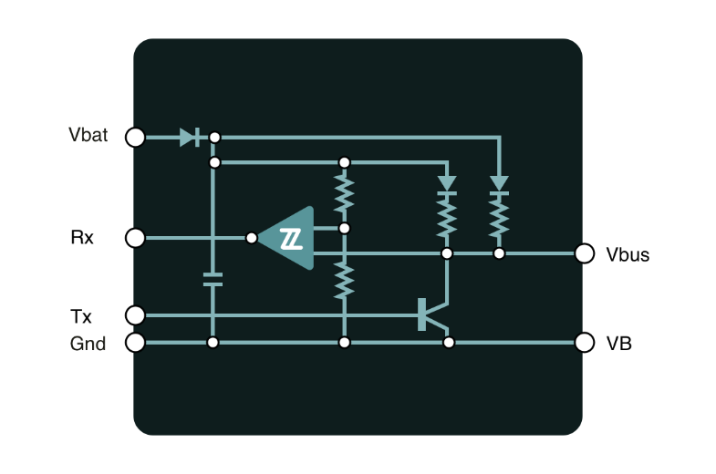
Figure 22. LIN Transceiver.

LIN Bus Line

The information in the LIN Network is transmitted through a single wire, which reduces implementation costs. Figure 23 shows an example of a LIN Bus Line, where each node contains a unique address that can be defined by a hardware one-time programmable (OTP) process, or assigned by the Master node just after powering up the networks.

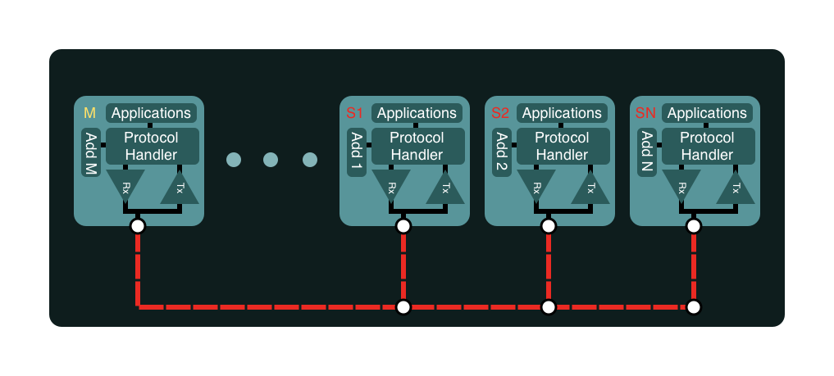
Figure 23. LIN Bus Line.

LIN Signal

The LIN signal transmits the information with Less Significant Bit (LSB) at the beginning and Most Significant Bit (MSB) at the end of every Transmitted Byte. The signal states (Dominant and Recessive) can be differentiated from the voltage level transmitted in the single wire of the network, when the voltage is above 60% of the Voltage Supply ($V_{SUP}$) the signal is interpreted as Recessive, when voltage is below 40% of $V_{SUP}$ the signal is interpreted as Dominant (Figure 24).
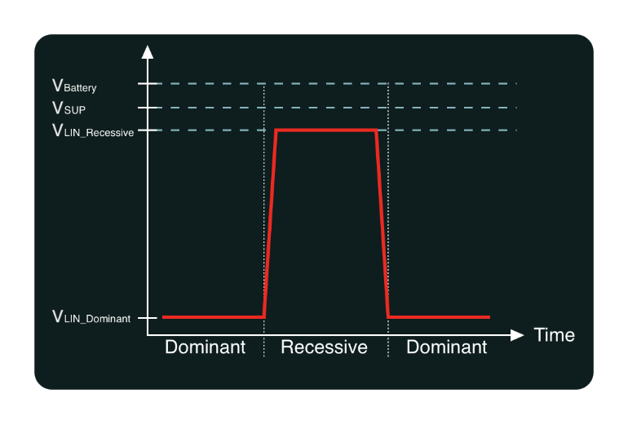
Figure 24. LIN Signal.

LIN Frame

The data transmission is composed of a message header and a message response (Figure 25), where the Header is transmitted by a Master Node and the Message is transmitted by Slave Nodes (Figure 26).

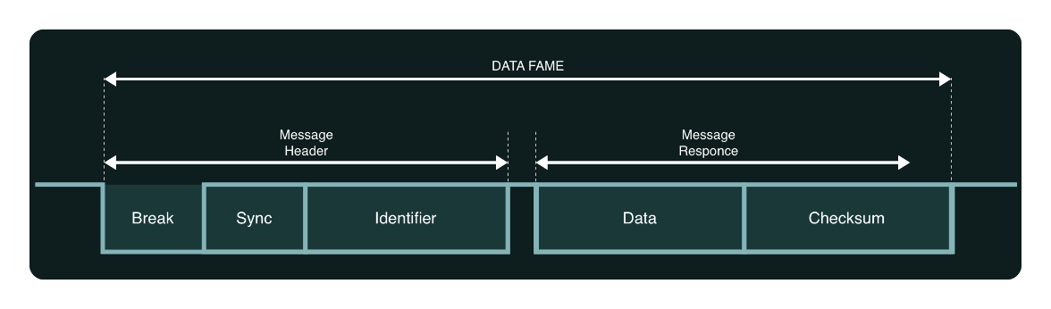
Figure 25. LIN Data Frame.

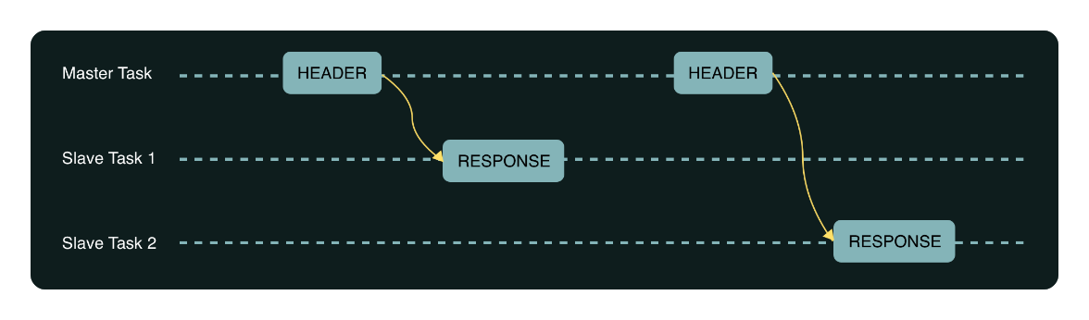
Figure 26. LIN Data Frame Transmission.

Master Header

Break Field

This field is always transmitted by a Master task and is used to determine that a new message will be transmitted on the network. This signal must transmit at least 13 nominal bits to allow Slave nodes to detect at least 11 nominal bits [4].

Sync Byte Field

This field always transmits a single Byte with a value 0x55 (Figure 27). This field must always be detected by Slave nodes to allow synchronization transmission between master and slaves.

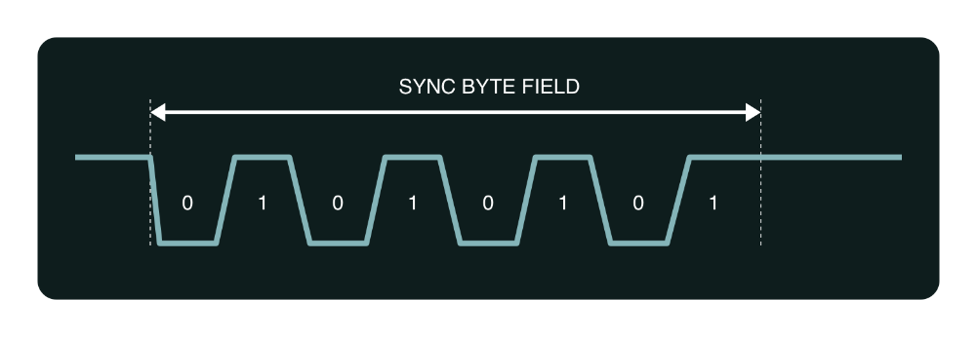
Figure 27. LIN Sync Field.

Protected Identifier Field

The byte transmitted in this field determines the action that will be executed by one or multiple slave nodes. The first 6 bits (ID0-ID5) of this field are used as an identifier allowing a maximum 63 action tasks per master node, the las two bits (P0 AND P1) are used to calculate the parity of the first 6 bites and determine if some Byte was transmitted with errors (Figure 28).
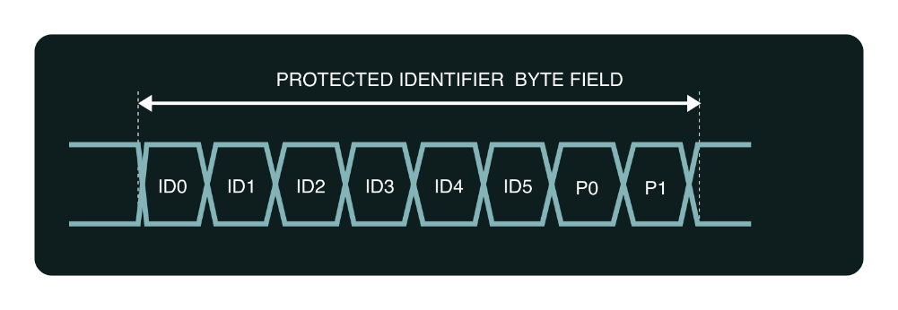
Figure 28. LIN Protected Identifier Field.

The parity bits (P0 and P1) can be calculated with formulas the following formulas:

$$P0 =ID0 ⊕ID1 ⊕ ID2 ⊕ ID4$$ | (3-3)

$$P1 =¬\left( ID1 ⊕ID3 ⊕ ID4 ⊕ID5\right)$$ | (3-4)

Response

The response frame is composed of data section and checksum sections where the data section can contain between one to eight bytes, and 1 byte for the checksum section (Figure 29).

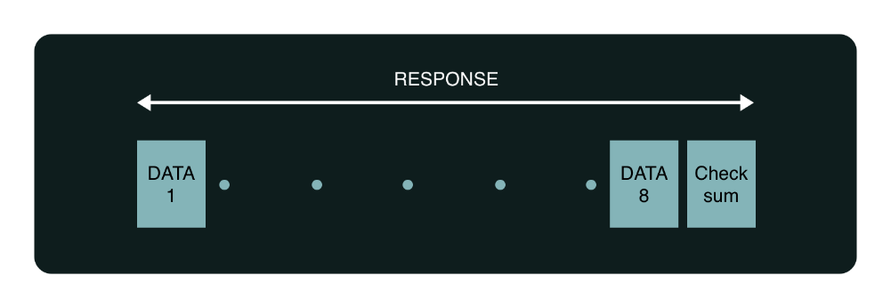
Figure 29. LIN Response.

The checksum is the last part of a LIN message, and contains the sum with carry of every byte in the data section, that is equal to the sum of all data sections and subtracts 255 every time that sum is greater or equal to 256.

Thread

The Thread protocol provides a secure communication network capable of rejecting devices to join to the network unless they are authorized and all data transmitted is encrypted. Also, this protocol can be used in small or large networks as it is designed to optimize the network operations based on to the required bandwidth use.

OSI Model

The Thread protocol is only situated in transport and network layers of OSI model. The data link and physical layers of Thread communication are handled by the IEEE 802.15.4 standard (Figure 30).
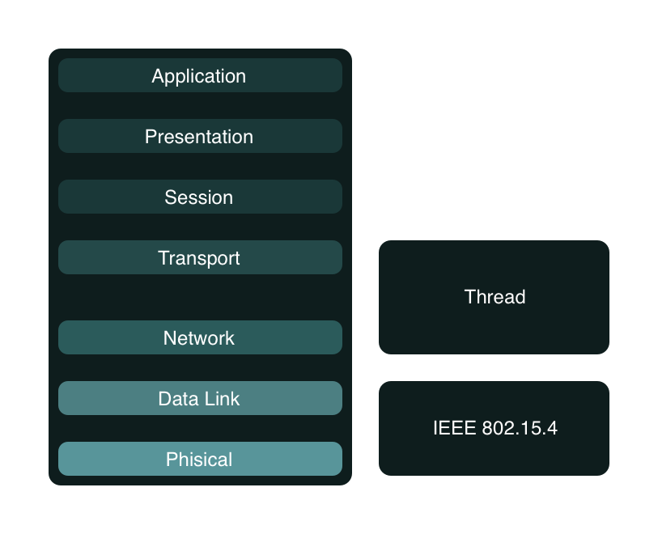
Figure 30. Thread in the OSI Model.

IEEE 802.15.4

The IEEE 802.15.4 standard is wireless network protocol commonly used for wireless sensors communications. This protocol is in data link and physical layers of the OSI model. In the physical layer, it is in charge of translating the data transmitted over the air to bits and back again. In the data link layer, it provides the Personal Area Network Identification (PAN ID) and network discovery as well as the joining process required to create the network. This protocol is not only implemented by Thread for data link and physical layers, it is also used for ZigBee, wirelessHART, MiWi, and Z-Waves protocols, among others. This protocol can be implemented in a peer-to-peer or start topologies, but it does not support mesh topology on its own (Figure 31). Even when the range for each node of the IEEE 802.15.4 standard works in moderate distance, the amplification is possible if the network topology is appropriate to the required needs.
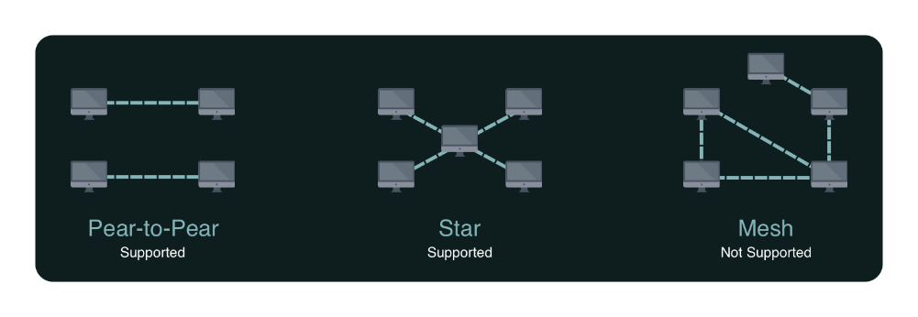
Figure 31. Supported Topologies in 802.15.4 protocol.

Radio Frequency

The IEEE 802.15.4 standard utilizes multiple modulation schemes depending on the frequency range and geographical location. Table 3 shows the available Radio Frequency (RF) bands, channels, and modulation schemes for the IEEE 802.15.4 standard.

Table 3. IEEE 802.15.4 Radio Frequency Modulation.
RF Band | Frequency Range (MHz) | Chanel Numbers | Modulation Schemes | Data Rates (kbps) | Geographical Area
868 MHz | 868.3 | 0 (1 channel) | BPSK  O-QPSK  ASK | 20  100  250 | Europe
915 MHz | 902-928 | 1-10(10 channels) | BPSK  O-QPSK  ASK | 40  250  250 | America, Australia
2400 MHz | 2405-2480 | 11-26(16 channels) | O-QPSK | 250 | Worldwide

Type of devices

Only two types of devices exist for the IEEE 802.15.4 standard. The capabilities for each device are shown in Table 4 and Table 5.

Table 4. IEEE 802.15.4 Full functional device characteristics.
Full Functional Device (FFD)
Any topology
Network coordinator
Talk to any other device
More functionality than Reduced Function Device
Bigger memory footprint than Reduced Function Device

Table 5. IEEE 802.15.4 Reduced functional device characteristics.
Reduced Functional Device (RFD)
Limited to be a leaf device
Cannot become a network coordinator
Talk talks only to network coordinator
Less functionality than FFD
Less memory footprint than FFD
Can stay in sleep mode to reduce battery consumption

Transmission Modes

The transmission modes for the IEEE 802.14.5 standard depend on the configurations and capabilities of every node in the network. The main constraint is the power supply because if a node works with batteries, it should be configured to transmit data in indirect mode.

Direct Mode

For direct mode, the information packet is transmitted immediately from the coordinator to the node device, which is always listening for Rx data (Figure 32). This is the scenario where nodes receive a constant voltage supply.

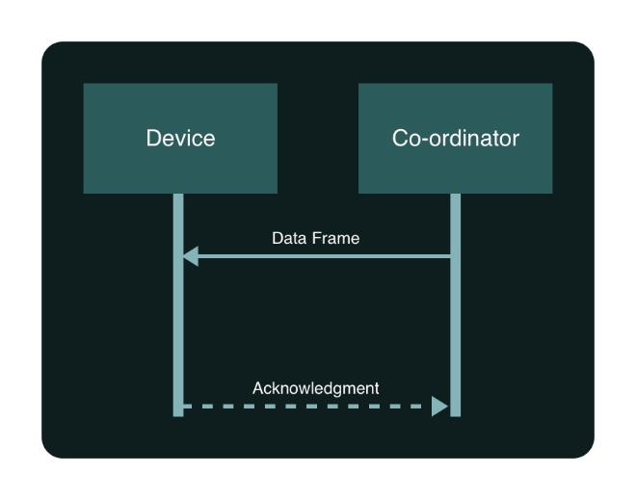
Figure 32. IEEE 802.15.4 Direct Mode Transmission.

Indirect Mode

For indirect mode, the information packet is held by the coordinator device in Tx buffer until the node device pulls the information (Figure 33). This scenario is for devices that use batteries, as a result, this indirect transmission mode reduces the voltage consumption.

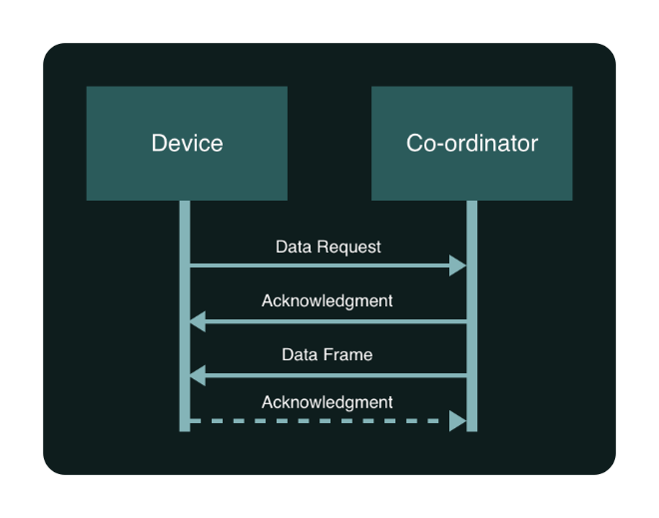
Figure 33. IEEE 802.15.4 Indirect Mode Transmission.

Data Frame

The IEEE 802.15.4 data frame, is composed of multiple nested sections (Figure 34). The PHY Protocol Data Unit (PPDU) is the frame that contains the data bits transmitted in the physical medium. The PPDU contains the synchronization header, PHY header and PHY Service Data Unit (PSDU) sections. All these frame sections are for the Physical Layer in the OSI Model.

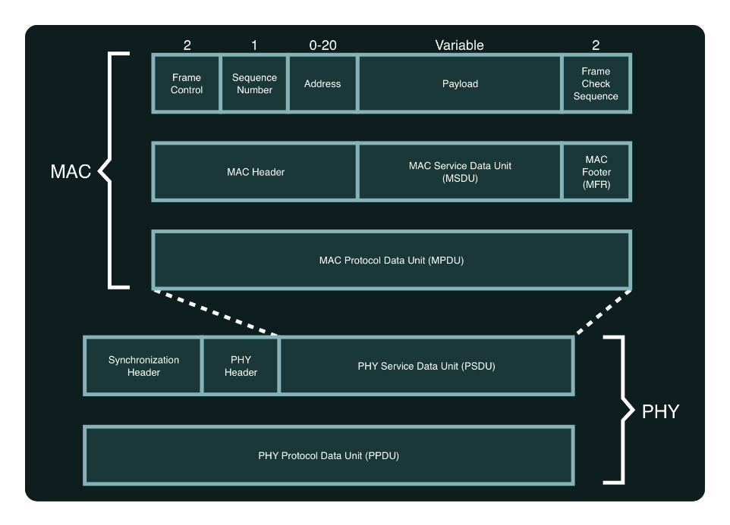
Figure 34. IEEE 802.15.4 PHY & MAC Data Frame.

The PSDU in the physical the layer is also the MAC Protocol Data Unit (MPDU) for the data link layer, which is composed of below sections.

MAC Header

This section indicates the start of MAC frame, the format address for destination devices and/or source address. The MAC header section also controls the acknowledgement of data transmission to ensure that all the information was transmitted correctly.

MAC Service Data Unit (MSDU)

The MSDU, also called payload, contains the data that will be transmitted in the data link layer. The length for this section is variable.

MAC PAN Information Base (PIB).

The PIB is a list of characteristics contained in each node in an IEEE 802.15.2 network used by data link and physicals layers. Some examples are listed in Table 6.

Table 6. IEEE 802.15.4 PIB Characteristics examples.
Examples of PIB characteristics
Acknowledge wait duration
Association permit
Extended address
Short Address
Rx on when idle
Security mode

Topology

The Thread topology is composed of four elements: border router, router, router eligible device, and sleepy end devices. Figure 35 shows an example of the Thread network and how border routers connect the Thread network to the Wi-Fi network.
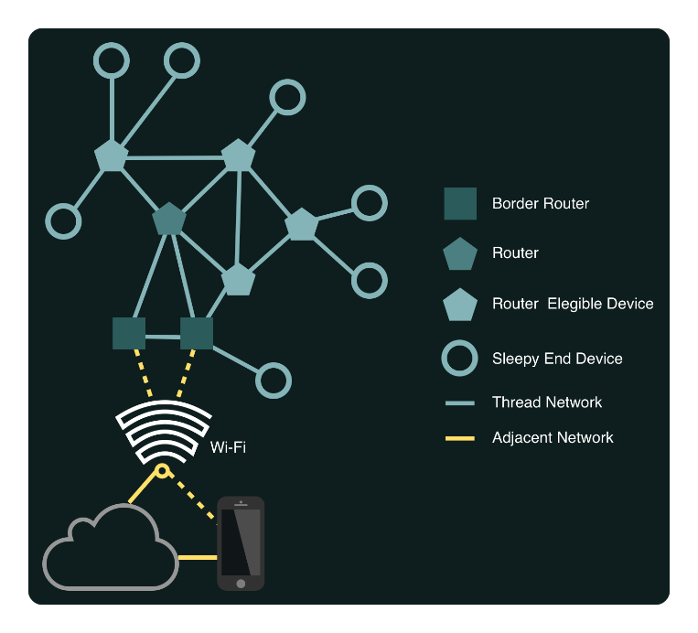
Figure 35. Thread Network Topology Example.

Border Router

This component provides connectivity from the 802.15.4 network to adjacent networks for other physical mediums like Wi-Fi, Ethernet or USB, and every Thread network has at least one border router.

Router or Leader

This component provides routing services to nodes in the network; it is also in charge of security services for devices trying to join the Thread network. These kinds of devices are not designed to sleep and they should have constant power supply

Router-Eligible End Device (REED)

The REED devices can become a router, but due to initial conditions they do not start working as a router.

Sleepy End Device (SED)

The SED devices are host devices that only can communicate with their parent routers, and cannot forward messages from other devices. These kind of devices are designed to work with batteries.

Design of product

In order to be able to connect vehicle networks with smart-home networks, LIN, CAN, IEEE 802.15.4, and Thread protocols must be tested. This section explains the practices executed to test the four protocols using hardware from NXP. Table 7 shows the hardware required to execute the four practices.

Table 7. Hardware required to execute the practices.
Hardware Name | Hardware Photo
SAM V71 Xplained Ultra module | 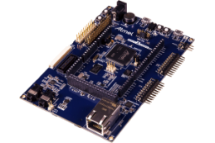
MC1323x Development Kit | 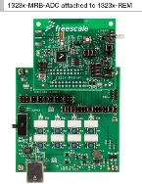
FRDM-K64F module | 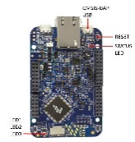
CR20A module | 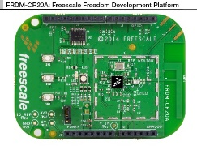
FRDM-KW24D512
CAN Vector tool VN1630 | 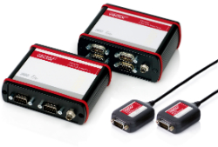
Test Bench | Must take photo from laboratory

The modules listed in Table 7 requires specific software to be able to modify the functionality of each module. Anyone who wants to reproduce these practices must download or buy the software showed in Table 8.

Table 8. Software required to execute the practices.
Software Name | Description
WinIDEA | IDE, which contains the required tools for embedded software development.
Putty | Open source terminal emulator, network file transfer and serial console
BeeKit | Software to create, modify, save and update wireless network solution for NXP hardware based with NXP software stack.
CodeWarrior | Integrated Development Environment (IDE) published by NXP to create, modify, compile and debug software for microcontrollers, microprocessors and digital signal controllers.
Kinetis Design Studio | Integrated Development Environment (IDE) for Kinetis MCUs

LIN

Application and Conditions

In order to communicate with LIN network is necessary to provide a software solution with defined interfaces that will allow creating the LIN frame through the UART controller available in the SAM V71 evaluation kit.

Process

In order to transmit LIN message packets with the SAM V71, the software in the board must execute the two functions listed in Table 9. This function must be created using WinIDEA software. The technical information required to create these functions in SAM V71 is listed in “SAMV71-Xplained-Ultra_User-Guide" [13] file that can be downloaded from the Atmel website.

Table 9. Functions required to transmit data in the LIN network with SAM V71 board.
1 | Setup the board with function Lin_Init (uint16_t LinBaudrate)
2 | Send data frames with function Lin_SendFrame (uint8_t LinPid)

Create LIN initializer function

The first function for SAM V71 to setup the board must meet the requirements shown in Table 10.

Table 10. LIN Initializer Function Requirements.
LIN Initializer Function Requirements
1 | Set function as: void Lin_Init (uint16_t LinBaudrate)
2 | Configure lower layer of UART driver for SAM V71 Xplained Ultra board
3 | Setup baud rate
4 | Interrupts shall be configured for each data byte to be transmitted or received
5 | This function shall provide to the lower layer a function callback (Lin_Isr) to be invoked at any of the RX or TX UART interrupts

Once the baud rate has been defined, the UART driver configuration must define the channel ID, parity, UART mode, and Tx callback function that will be used to detect when bytes are transmitted. The last step in LIN initializer function will be to activate the Tx interruption.

Create send LIN frame function

The second function for the SAM V71, must meet the requirements shown in Table 11. The information transmitted should be visible in an oscilloscope.

Table 11. Send LIN Frame Function Requirements.
Send LIN Frame Function Requirements
1 | Set function as: void Lin_SendFrame (uint8_t LinPid)
2 | This function will send a predefined header as per the LIN protocol with the rate define in the Lin_Init function
3 | This function shall be asynchronous, i.e. it will trigger the "send command" and will continue its operation without waiting for the header to be completely sent over the bus
4 | The header shall be composed in order of:  - 1. Break = (from 10 to 13 bit times) ideally >= 13 bit time  - 2. Synch = 0x55  - 3. ID = LinPid

CAN

Application and Conditions

The objective of this practice is to transmit a CAN frame from SAM V71 to a real physical CAN layer in a test benched equipment to execute some actions.

Process

Analyze CAN Network from Test Bench Equipment

Connect the CAN Vector tool VN1630 to the CAN physical layer of the corresponding test bench to determine the information listed in Table 14.

Table 12. Information to be Determined from Test Bench.
Information to be determined from test bench
1 | The actual CAN baud rate for communication in
2 | The CAN message (CAN ID and CAN Data) derived from the following actions:  - left directional active  - right directional active  - high beams active  - optical horn active

Once baud rate and CAN frames has been determined with CAN Vector tool, download the software package for SAM V71 from the Atmel website. This software package contains mcan.c, mcan.h and mcan_config.h files, which contain functions to configure the CAN transceiver in SAM V71 board and send the CAN frames. The hardware is already prepared with a resistor of 120 Ω. So, no additional hardware is required.

Create SAM V71 software

The software package for SAM V71 board is already prepared to configure any of the two available CAN transceivers, in order to use any CAN transceiver from SAM V71, the hardware must be configured. This configuration can be done with functions MCAN_Init and MCAN_Enable located in file mcan.c from software package. You must only select the transceiver that will be connected to the test bench, and use the struct mcan0Config or mcan1Config to configure the corresponding transceiver.

Once the transceiver hardware is configured, the baud rate must be set in the SAM V71 board, this configuration must be done changing the constants values for bit rate, propagation segment, phase segment 1, phase segment 2 and sync jump in the file mcan_config.h located in the software package for the corresponding transceiver.

Once the transceiver and baud rate is configured, the CAN message must be configured using function MCAN_ConfigTxDedBuffer with the corresponding CAN Id, CAN Id type and CAN DLC.

Once the software is loaded in the SAM V71 board connect the board to the test bench CAN networks and execute the software to control, left directional light, right directional light, high beam lights, and optical horn.

IEEE 802.15.4

Application and Conditions

The purpose of this practice is to validate the communication and data transmission between the coordinator and end device connected with an IEEE 802.15.4 network.

Process

Create base code with BeeKit

Execute BeeKit executable program to generate the base code for MC1323x Development Kit. Administrator authorization is required to execute BeeKit as Figure 36 shows the program to be executed.

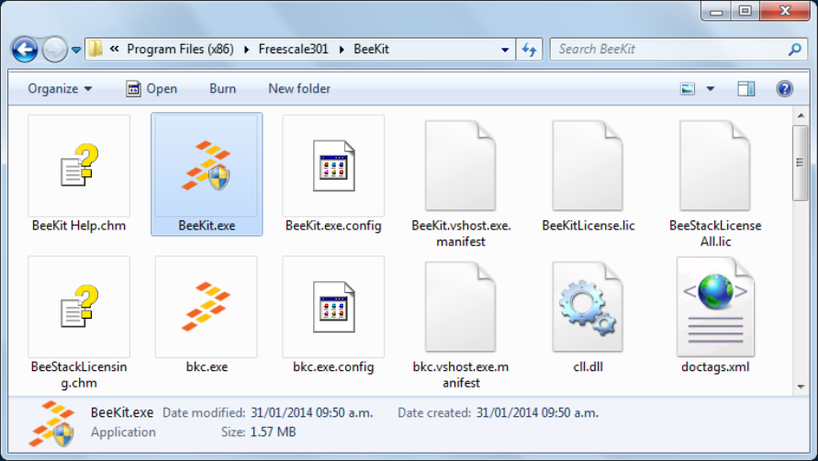
Figure 36. Open BeeKit software.

Once BeeKit is opened, click on “Select Other Codebase” in start page tab as shown in Figure 37.

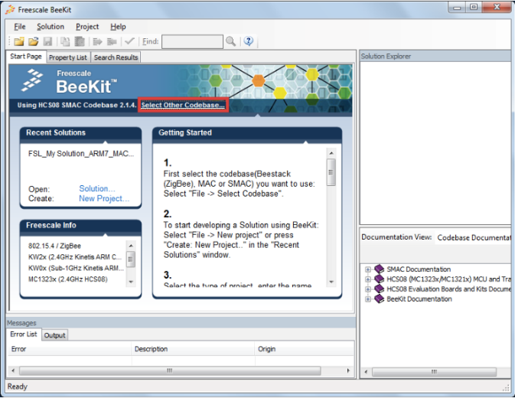
Figure 37. Select Codebase in BeeKit.

Once a new window is shown, select the HCS08 MAC codebase 2.6.1. Figure 38 shows the code base to selected. Is important to use the correct code base since BeeKit supports multiple hardware and IDEs. After the code base was selected, press the button “Set Active” to close the window.

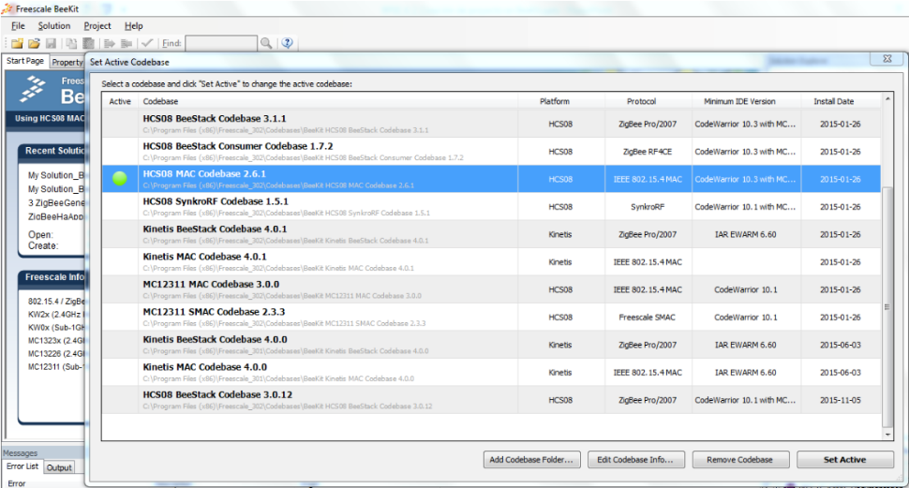
Figure 38. Chose codebase in BeeKit.

Create a new project in the BeeKit selectin File > New Project, Figure 39 shows the menu option selected.

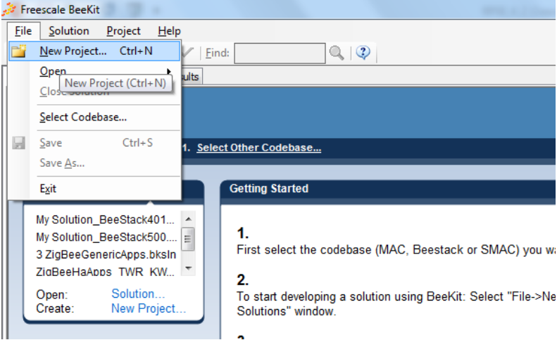
Figure 39. Create Project in BeeKit.

Select the name and location for the project and “Demo Non-Beacon (Coordinator)” template for the coordinator hardware and click the “OK” button once all fields are complete. Figure 40 shows the windows that will be displayed in BeeKit.

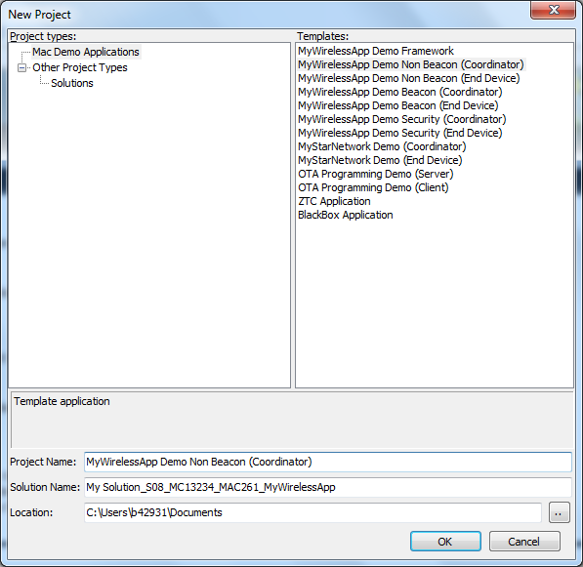
Figure 40. Select BeeKit Project Location and Template in BeeKit.

Once the previous window has been closed, the project configuration window will be showed, select the MC1323x-REM hardware and click button “Next” as Figure 41 shows.

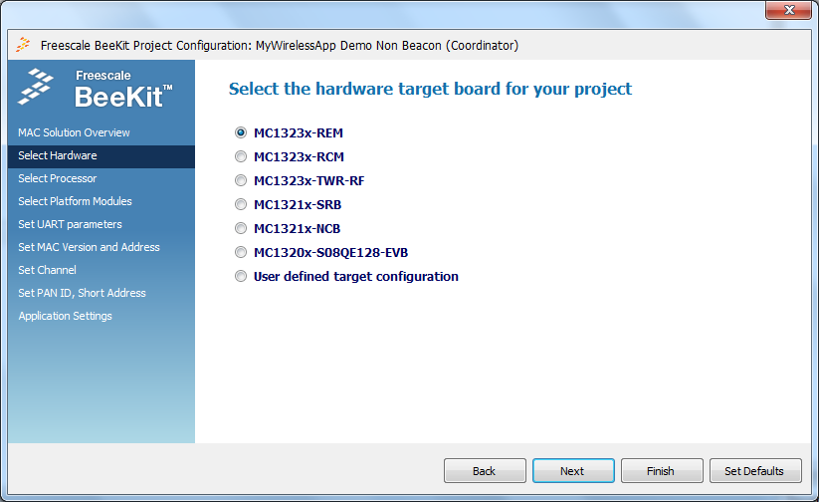
Figure 41. Select Development Board in BeeKit.

Select the MC13234C processor hardware. Figure 42 shows the windows that will be displayed.
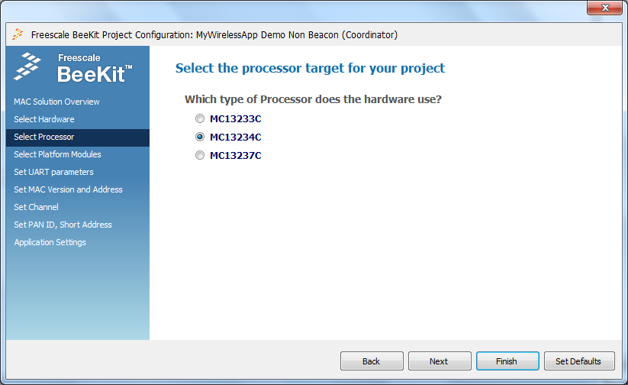
Figure 42. Select Processor in BeeKit.

Select LEDs and Keyboard modules and click button “Next” as Figure 43 shows. The CMT, Low Power Module, and ICC modules are not required for this practice.

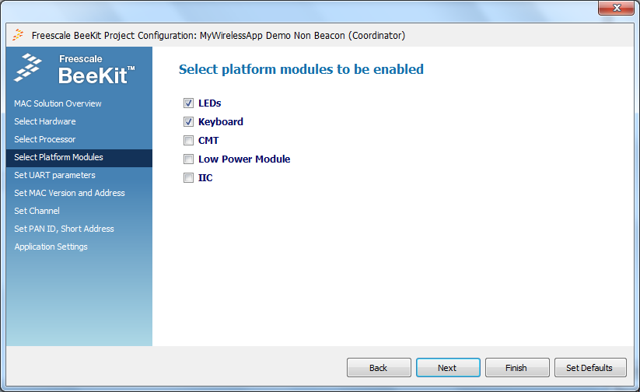
Figure 43. Choose Modules in BeeKit.

Enable UART on USB by clicking the checkbox, and select the baud rate that will be used in the terminal. Figure 44 shows the corresponding windows for this configuration. It is important to have the same baud rate in BeeKit and Putty to be able to see terminal debug messages.
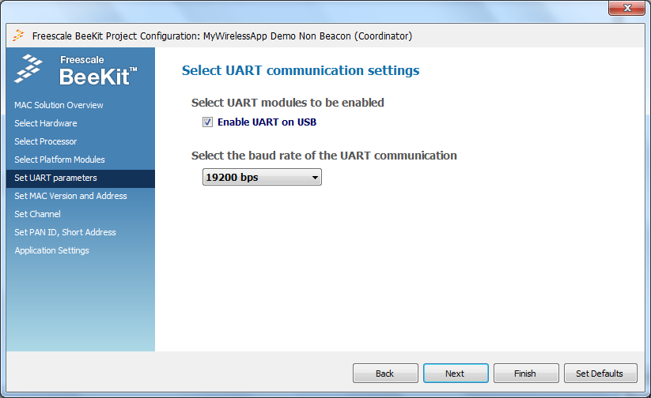
Figure 44. Enable UART in BeeKit.

Select the latest IEEE 802.15.4 MAC Version 2006, set the extended MAC address and click button “Next” as Figure 45 shows.

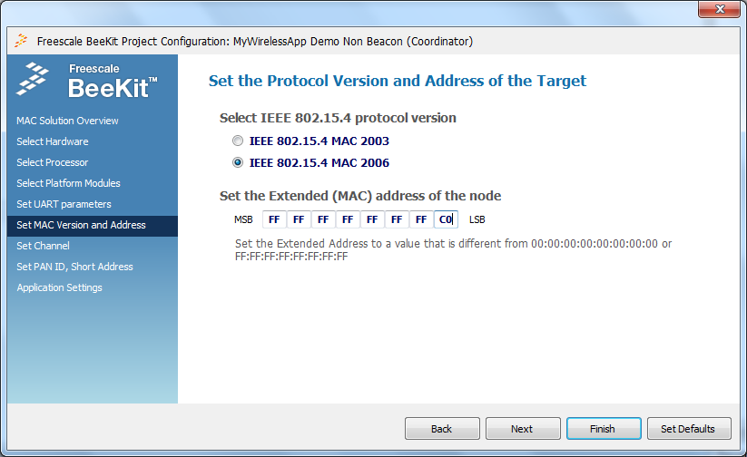
Figure 45. Select Protocol Version in BeeKit.

Select one single radio frequency channel that will be used to transmit the information and click on the “Next” button as Figure 46 shows. More than one single channel can be selected, but for this practice, only one channel is required.
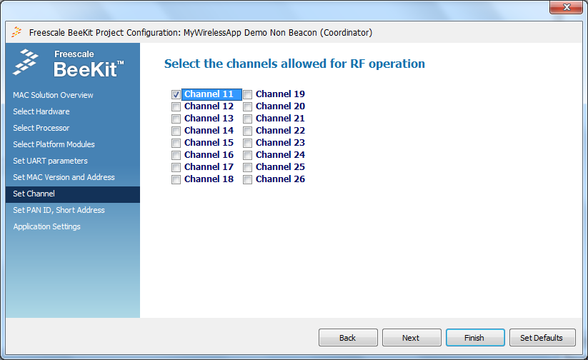
Figure 46. Select Channels in BeeKit.

Set the PAN ID and short address for the coordinator device as shown in Figure 47.

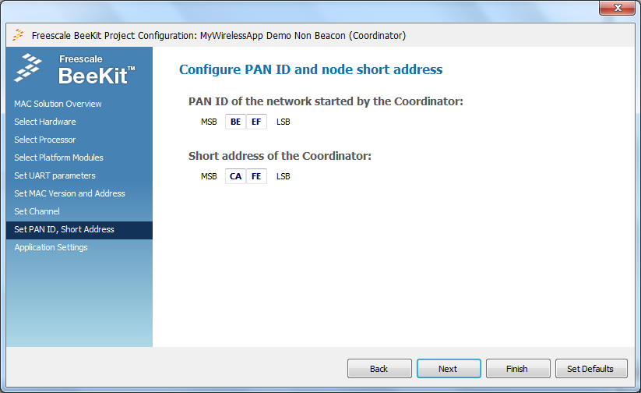
Figure 47. Configure PAN ID.

Figure 48 shows how to set the maximum pending packets in the coordinator; it will reserve memory space for message buffering. Once the maximum number of pending packets is set, press the “Finish” button.
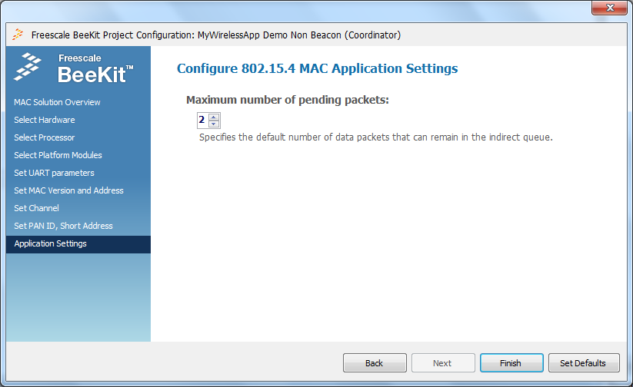
Figure 48. Set Maximum of Pending Packets.

Once the code base for coordinator was created with BeeKit, all previous steps must be repeated to create the code base for end device. The process to create the code base for end device is the same than the processe to create the code base for coordinator but with only difference of selecting “Demo Non-Beacon (End Device)” instead of “Demo Non-Beacon (Coordinator)” template in the “New Project” window (Figure 40) .

Once BeeKit has created the code bases, it must be imported to CodeWarrior to be able to modify it and flash the hardware boards as shown in Figure 49.

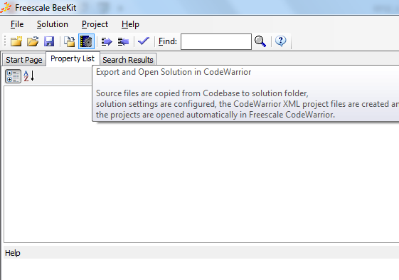
Figure 49. Export to CodeWarrior.

Once code base for coordinator has been imported to CodeWarrior IDE, edit the corresponding code base to meet the requirements from Table 13. When code base is completed, download the program to the coordinator board of MC1323x Development Kit.

Table 13. IEEE 802.15.4 Coordinator Requirements
Demo Non-Beacon (Coordinator) Requirements
1 | Each time that a message packet is received from end device, the coordinator will update its led states to reflect the same state of end device.
2 | Each time that a message packet is received from end device, the coordinator will print in terminal the sender address, LQI and payload size.

Edit the base code for end device, in order to meet the requirements listed in Table 14. Once software edition is complete flash the end device hardware from MC1323x Development Kit and execute the programs in coordinator and end device.

Table 14. IEEE 802.15.4 End Device Requirements
Demo Non-Beacon (End Device) Requirements
1 | Create a timer that will be executed every 3 seconds. In every execution, the end device will send a message packet to the air with a counter value within the range from 1 to 4.
2 | See the counter value reflected in hardware led.
3 | Each time that a button is pressed on end device hardware, the counter value will be set to the corresponding button number and message packet will be sent immediately.

Thread

Application and Conditions

This practice is executed to adapt a custom application using the NXP Thread Stack for IPv6 communication by enabling additional accelerometer functionality to a stack example provided by NXPO. In this practice, the sensor functionality will be integrated in a Thread End Device and a Thread Router or Border Router will be modified to receive and display the COAP packets.

Process

Clone End Device project

In order to create the Thread project, the Thread stack package and the Kinetis Project Cloner executable from the NXP website, they must be downloaded. One the Kinetis Project cloner is executed, select the end_device_freertos example as is showed in Figure 50 and validate the creation of the project with the corresponding destination root path.

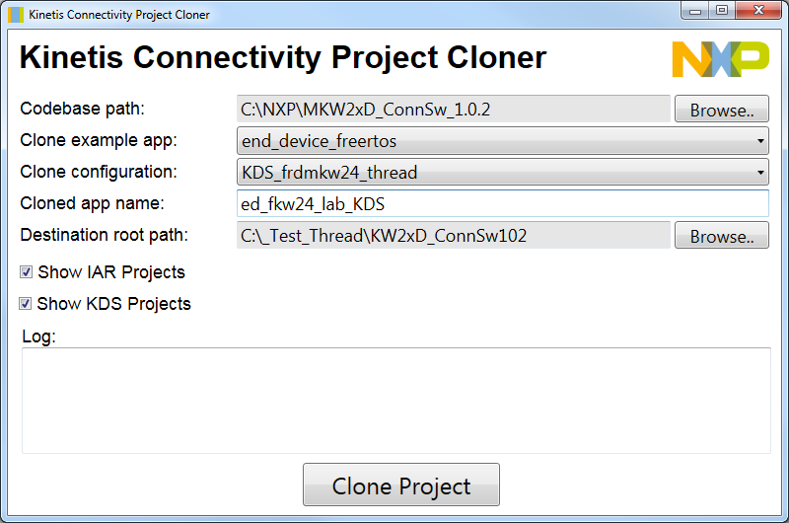
Figure 50. Kinetis Connectivity Project Cloner.

Configure KDS

Once KDS is open, import the cloned project by clicking on menu File >Import. When the Import windows is shown, select the option “Existing Projects into Workspace” and select the root path where the cloned project created with Kinetis Connectivity Project Cloner was stored (Figure 51).

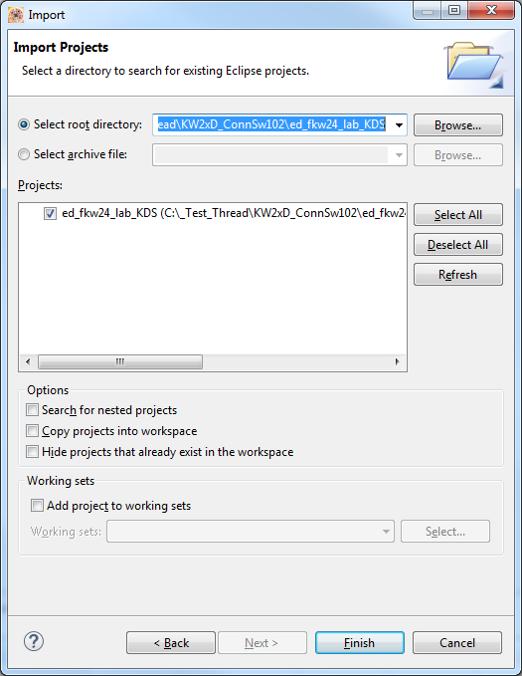
Figure 51.Import Project in KDS.

Copy Sensor Files

Copy the source and header files for fsl_fxos and app_accel_sensor modules as shown in Figure 52 and paste them under “..\drivers\” and “...\middleware\wireless\nwk_ip_1.2.1\examples\common” paths of the project created in KDS as Figure 53 shows.

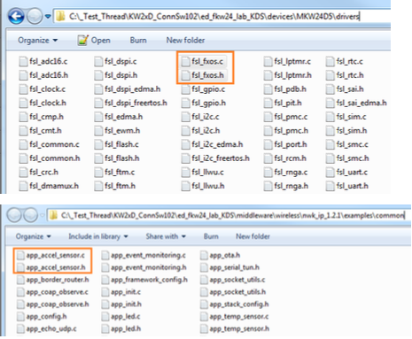
Figure 52. Source and Header files location for Thread practice.

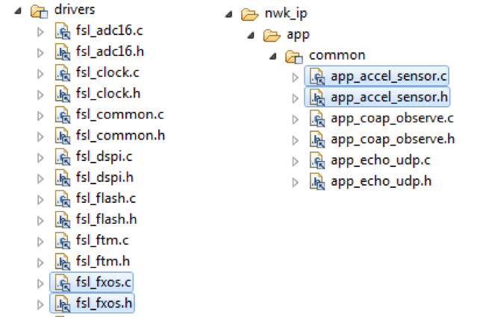
Figure 53.File destination of sensor modules for Thread practice.

Source code modifications on project

Include the app_accel_sensor and pin_mux headers in end_device_app.c file, add an URI path and event number for accelerometer information and initialize the accelerometer with the function APP_InitAccelerometer.

Modify the function Stack_to_APP_Handler to enable the accelerometer hardware with function APP_EnableAccelerometer, when an end device has joined to the network.

Register the accelerometer CoAP URI in function APP_InitCoapDemo and modify the switch behavior to send the accelerometer data in function APP_AppModeHandleKeyboard.

Build and download the projects for end device and border router clicking on the button with a hammer icon (Figure 54).

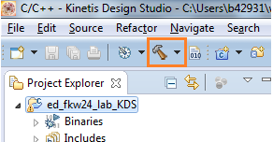
Figure 54. KDS build and download button.

Finally, connect CR20A and FRDM-KW24D512 modules to the terminal to observe the interaction between both devices using shell commands.

Results

LIN

For the LIN practice, the steps required to configure the hardware and transmit LIN frames using the SAM V71 Xplained Ultra board are explained. The baud rate value was 150200 bits per second. The signal sent by SAM V71 can be observed in Figure 55.

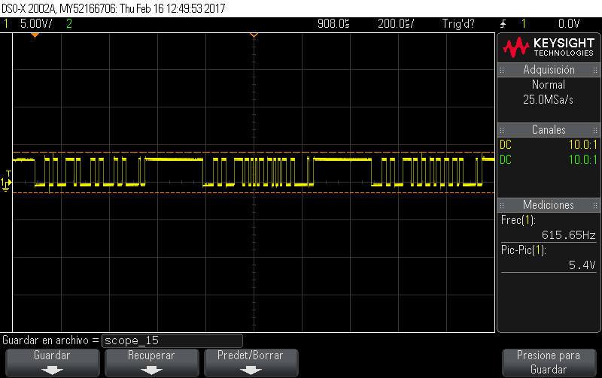
Figure 55. LIN Frame data transmission.

After observing the signal with more detail, the signal showed a trace of noise (Figure 56). It was not possible to determine if this noise affects the communication since it was not tested in a functional LIN network.

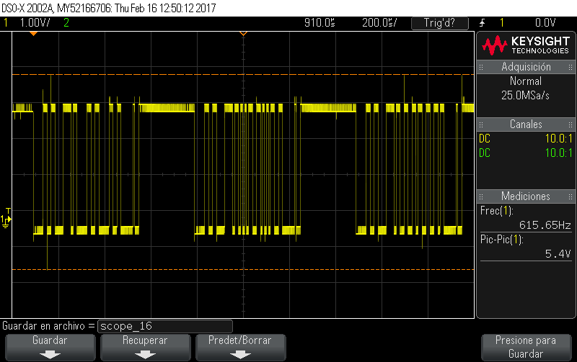
Figure 56. Noise in LIN Frame data transmission.

CAN

In this practice, the required step to configure the end-point for a CAN network was shown. The CAN IDs found with CAN Vector tool VN1630 for each required action are listed in Table 15.
Table 15. CAN IDs found in test bench.
Action | CAN ID | DLC
Left directional active | 0x1A0 | DLC3
Right direction active | 0x1B0 | DLC3
High beams active | 0x123456A0 | DLC4
Optical horn active | 0x123456B0 | DLC4

The values used to calculate a baud rate of 110 bps are listed in Table 16. We found that the standard formula did not work since the software package applied its own formula.

Table 16. CAN segments values to calculate baud rate.
Section | Value
MCAN0_BIT_RATE_BPS | 500000
MCAN0_PROP_SEG | 2
CAN0_PHASE_SEG1 | 11
MCAN0_PHASE_SEG2 | 11
MCAN0_SYNC_JUMP | 4

It was found that when the time quanta in SAM V71 board is not equal to the test bench, the SAM V71 cannot establish a link with the existing network. Also, when the transmission line does not have its corresponding resistor in terminal, it does not achieve a coupling between devices.

As a result, the corresponding message (Table 15) activates the corresponding action using the signals shown in Figure 57.

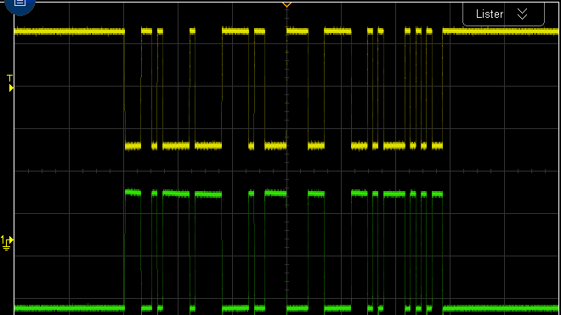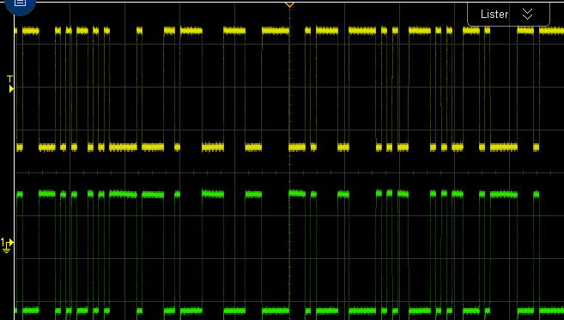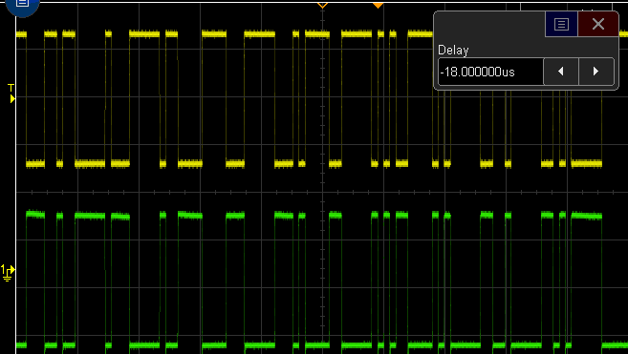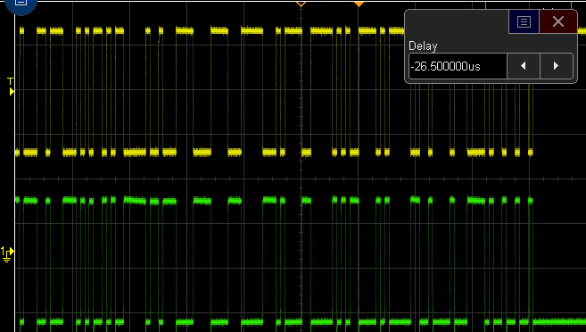
Figure 57. CAN Signals sent to test bench.

IEEE 802.15.4

Understanding the Application Programming Interface (API) created by Beekit and used in the code bases was the most difficult part of this practice, but once it was understood, the code edition was fast.

In this practice, the association process in an IEEE 802.15.4 network as well as the data transfer between FFD and RFD was validated. Also, how the software stack implemented for MC1323x Development Kit handles all the complex processes required to implement and configure the IEEE 802.15.4 was checked.

Thread

Just as the IEEE 802.15.4 practice, the most difficult part of this practice was to understand the software stack API for Thread. Once the API was understood, the software modification was easy to apply.

Figure 58 shows the communication log between CR20A and FRDM-KW24D512 modules. These logs show the accelerometer values sent from the end device to the coordinator once the connection was established. During the development process of this practice, a problem was found where the end device did not connect to the border router unless the shell command “factoryreset” was executed in terminal. Even when the code was reviewed for several days, it was impossible to determine the route cause for this behavior.

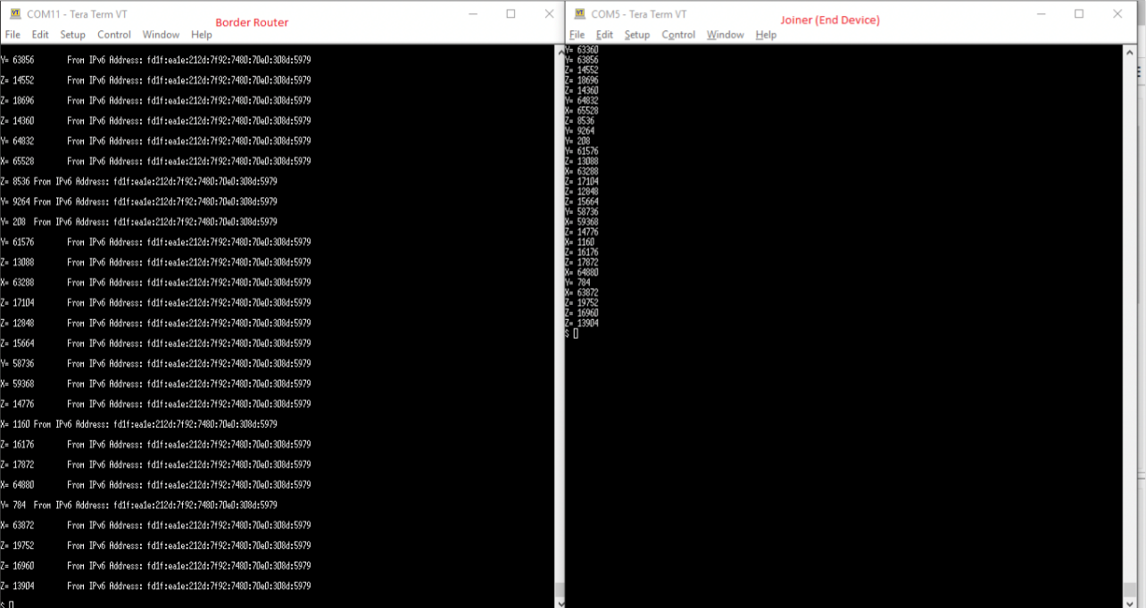
Figure 58. Tread communication Log.

Discussion

Even when CAN and LIN cannot be substituted in the automotive industry today, Thread and CoAP are only two of many available options in smart home wireless networks like ZigBee, Z-Wave, dotdot, or even Bluetooth Low energy, among others. Since smart home networks are considered a new area of investigation and product development and every wireless network technology provides advantages and disadvantages, the industry has not defined a standard wireless network for smart home communication.

The understanding of the IEEE 802.15.4 standard is the base knowledge to use not only in Thead protocol, but also for other protocols for smart-home wireless connections like ZigBee or Z-Wave, which indicates that the study of IEEE 802.15.4 is the first step to develop a product that allows vehicles to communicate with smart homes.

One of the most notable advantages of Thread network over others smart home networks, is its iPv6 capability to transmit the data packages in the shortest way to the specific devices, but it also provides the best user experience for customers of smart home devices since IPv6 also allows the network to develop in easy way, not only for the number of nodes, but also in extension using the mesh topology.

The practices executed in this project only provide the background knowledge to start the development of a robust solution to connect vehicles to smart-home. Also, testing more wireless communication protocols based in IEEE 802.15.4 or maybe BLE for determining the best communication option to include in a vehicle, is also required.

The technology used nowadays for IoT was developed many years ago. One example is BLE, which was created in 2004 but it began to be used ten years later in 2014 when this technology was implemented in the iPhone 4S. The delay between technology creation and technology implementation is a scenario that can occur to Thread technology and probably this technology could be available in vehicles in many years to come. Regarding communication networks in vehicles, the forecast shows that CAN and LIN Network t will be not changed, but they will complement with other technologies.

Conclusion

In this document, an overview of embedded system communications is presented. The protocols presented could work together for an automotive to cloud network. Additionally, a discussion of the future of technology was descripted in each section. Also, from wired CAN and LIN protocols to wireless Thread were detailed. Finally, the point of view of author is presented in the last discussion.

References

[1] | Union, International Telecomunication, "International Telecomunication Union," 05 06 2012. [Online]. Available: http://www.itu.int/ITU-T/recommendations/rec.aspx?rec=y.2060.
[2] | Internet of Things Consortium, "Internet of Things Consortium," 2017. [Online]. Available: http://iofthings.org/iotc/.
[3] | BOSCH, "CAN Specification," BOSH, Stuttgart, 1991.
[4] | LIN Consortium, "www.lin-subbus.org," 24 11 2006. [Online].
[5] | Thread Group, "https://threadgroup.org/," 13 2 2017. [Online]. Available: https://threadgroup.org/.
[6] | NXP, "http://www.nxp.com," 2015. [Online]. Available: http://www.nxp.com/assets/documents/data/en/supporting-information/CORPORATE-OVERVIEW-DOC.pdf.
[7] | CAN in Automation, "https://www.can-cia.org," [Online]. Available: https://www.can-cia.org/can-knowledge/can/can-history/.
[8] | Bluetooth SIG, "https://www.bluetooth.com," 2017. [Online]. Available: https://www.bluetooth.com/about-us/our-history. [Accessed 06 2017].
[9] | Google Play, "Google play," [Online]. Available: https://play.google.com/store/apps/details?id=com.ducati.dml&hl=en. [Accessed 14 06 2017].
[10] | Ducati, "Ducati Miltistrada Link," Ducati, [Online]. Available: http://www.ducati.com/multistradalink.do. [Accessed 10 06 2017].
[11] | Apple, "App store," Nest Lab Inc., [Online]. Available: https://itunes.apple.com/us/app/nest-your-home-in-your-hand/id464988855?mt=8. [Accessed 23 06 2017].
[12] | NXP, "NXP," 2004. [Online]. Available: http://nxp.com/.
[13] | Atmel, "Atmel-42408-SAMV71-Xplained-Ultra_User-Guide.pdf," 09 2015. [Online]. Available: http://www.atmel.com/Images/Atmel-42408-SAMV71-Xplained-Ultra_User-Guide.pdf. [Accessed 11 07 2017].
[14] | Nokia, "The Future of Things," 8 11 2013. [Online].

